TEAM ROSTER AND WAIVER FORM
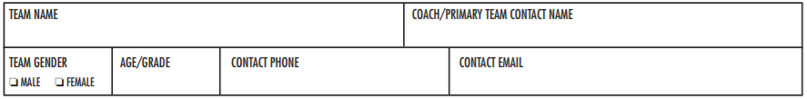
Waiver, Trademark and Management: Each participant and their legal guardian if the player is under the age of 18 must read, agree, and sign the Waiver Form. Participation in this event and its related activities contain risks. By signing this Waiver Form, I release and discharge Work Out West, event sponsors, event organizers, and Work Out West workers, employees and directors from any claims, demands, and causes of action arising from my child’s participation in their events and related activities. I fully understand that the participation in Work Out West Events and Programs contain a risk and that Work Out West (its employees, agents, directors, and owners) are not responsible for any lost or stolen articles of clothing or personal property. Player eligibility for collegiate sports and school district may vary. Event organizers are not responsible for determining each player’s eligibility. Contact your coach or athletic director and ask how your eligibility would be affected, if at all, before registering for this event.

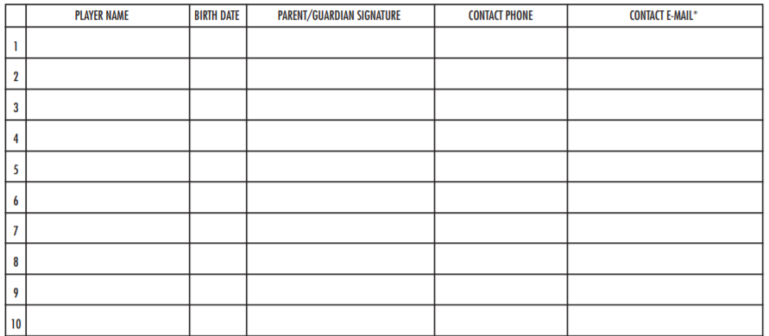
Circle a Skill Level For Your Team:
EXPERT (played in college or higher) INTERMEDIATE ADVANCED BEGINNER
We will do our best to pair up teams with similar skill sets
AS COACH/TEAM REPRESENTATIVE, I CERTIFY THAT THE INFORMATION WITHIN IS CORRECT TO THE BEST OF MY KNOWLEDGE.

PRINTED NAME: __________________________SIGNATURE: ______________________________ DATE: ___________

