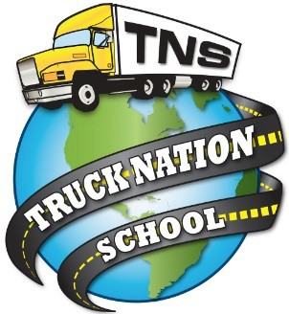TRUCK NATION SCHOOL
LOGO
2055 E. North Ave Fresno, Ca 93725 (559) 442-3696 WWW.TRUCKNATIONSCHOOL.COM

SCHOOL PERFORMANCE FACT SHEET

2019

Pro Program - 160 HOURS

On-Time Completion Rates
(Includes data for the two calendar years prior to reporting.)

This program is new. Therefore, the number of students who graduate, the number of students who are placed, or the starting salary you can earn after finishing the educational program are unknown at this time. Information regarding general salary and placement statistics may be available from government sources or from the institution but is not equivalent to actual performance data. This program was approved by the Bureau on 07/11/2019. As of 07/10/2021, two full years of data for this program will be available.

