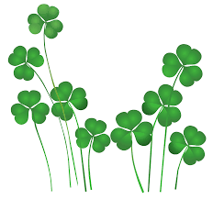



**03/02- Dr. Seuss Birthday PArty**

**03/07- Kona Ice**

**03/16- St. Patricks Day Party- Everyone wears Green**

**03/12-03/16- Scholastic Book fair**

**03/23-Storybook Parade**

**03/28- Visit From Easter Bunny**

**03/29- Spring parties/ Egg Hunt**

**03/30- School Closed**

**March Newsletter 2018**

**Reminders**

Please Remember Tuition is Due on **Friday**

Please remember to have your child here by 9:00am this will help us with staffing, and overall operation.

Please remember to label all your child’s personal belongings.

Happy March!!!

This month we have a lot of exciting events. We have our Dr. Seuss week, Story book Parade, St. Patrick’s day Celebration. Even a visit from the Easter Bunny! Plus Spring parties and egg hunts. The children will enjoy a lot of fun learning activities. We will learn about:

**Letter:**

Oo, Qq, Gg

**Number:**

17,18,19

**Shape:**

Rectangle

**Color:**

Green