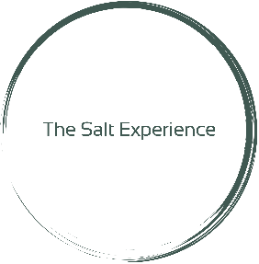
CONTACT / DISCLAIMER / RELEASE FORM

Salt Care is 100% natural, safe and drug free, providing effective long- term relief. It can be used as a complementary treatment to prescribed medications or as a sole treatment. When salt care is used as a complementary treatment, it can increase the effectiveness of prescribed medications and decrease the amount subscribed.

Although published studies do indicate that Salt Care has health benefits as an addition to more traditional forms of medicine, The Salt Experience does not claim to be a replacement for medication or any medical treatment of any kind. Only your personal physician or other health professional can best advise you on matters of your health. The research supporting the use of Salt Care was undertaken outside of the USA and hasn't been filed with the FDA for approval.

Salt Care should be avoided during the acute phase of any illness, including the following: infections accompanied by fever, acute active tuberculosis, cardiac insufficiency, COPD in third stage, bleeding, spitting of blood, contagious ailments, have use of an oxygen tank to aid breathing, alcohol or drug intoxication, unstable or uncontrolled hypertension, and acute stages of respiratory diseases.

I, as a client of The Salt Experience, hereby release The Salt Experience and its directors, officers, employees, agents and professional staff from all actions, causes of actions, suits, claims, liability, damages and demands of any kind, whether direct, indirect, special, exemplary or consequential, including interest therein of The Salt Experience which may occur as a result of any injury including death sustained by myself or others resulting from the receipt of Salt Care.

I fully understand the above disclaimer and use The Salt Experience at my own risk.

Signature:__________________________________________________ Date:__________________

Printed Name: ____________________________________________________ DOB: ____________

Parent Name /Signature( if under 16)____________________________________________________

Address: __________________________________________________________________________
Phone Number:

__________________________________

E-Mail Address:

__________________________________
Driver’s License/ State ID
Referred by/How did you hear about us?

__________________________________

