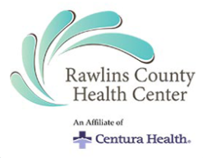

Craig Loveless Named CEO of Goodland Regional Medical Center – Goodland KS, and Rawlins County Health Center – Atwood KS

Date: June 10, 2021
To: All GRMC/RCHC Associates
From: Josh Neff – VP Integration, Centura
___________________________________________________________________
Following a national search in collaboration with the Board of Directors and leadership teams from Goodland Regional Medical Center, Rawlins County Health Center, and Centura Health, I am pleased to announce that Craig Loveless will serve as CEO, for both hospitals, effective June 14, 2021.
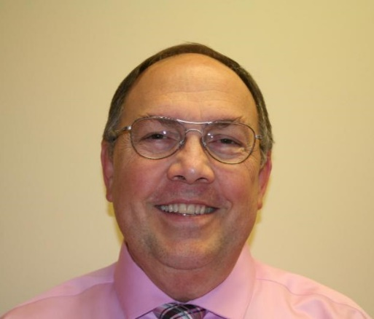
Craig brings many years of rural Critical Access Hospital operations experience to his role as the new CEO of GRMC and RCHC. Prior to his healthcare career, Craig was in wealth management and law. A native of Utah, Craig received a bachelor’s in business management from Brigham Young University. He then received his Juris Doctorate from Pepperdine University. Craig began his healthcare career in operations roles and has excelled at driving growth, building strong physician and associate relationships, as well as connecting with the communities he serves. In addition to his hospital leadership role, Craig serves on the Shared Services Board of the Colorado Hospital Association as well as the Colorado Rural Health Center, where he was previously the Chairman. Most recently, he served as CEO of Prowers Medical Center in Lamar, CO.
Craig is passionate about the importance of high-quality healthcare in rural communities. He believes there is a significant connection between the hospital and the community and for both to be successful both must thrive off each other.
Craig is married and has 5 adult children – 4 daughters and a son - is an avid sports fan, and he and his wife enjoy being outdoors and recreating in their spare time.
“I am looking forward to living in northwest Kansas, being involved in the community, and continuing to build on the great work both GRMC and RCHC have been doing to ensure our communities have two thriving healthcare systems” said Loveless.
I would like to take this opportunity to thank Andy Flemer for stepping in and taking the interim CEO role during this transition. I appreciate Andy’s willingness to jump in and start working with both boards and leadership teams in continuing to advance the respective missions of both organizations in the communities they serve. Andy has served in interim executive roles at Centura for the last year and a half. We are fortunate to have had a talented and mission-driven executive ready and able to assist us with our northwest Kansas managed hospitals. Please join me in thanking Andy for his dedication and commitment to both organizations, and wishing him all the best in his next adventure.

