Recommended Installation Pump
Our recommended pump is available for purchase for $550.00. For repeated use, Pump Flush must be used to completely clear the pump of all residue before and after each use. Klingstone Paths Pump Flush is available for $132.50 per 5 gallon pail. One application wand and uptake line are included with the aforementioned sale. Additional materials that installers will need are listed below.
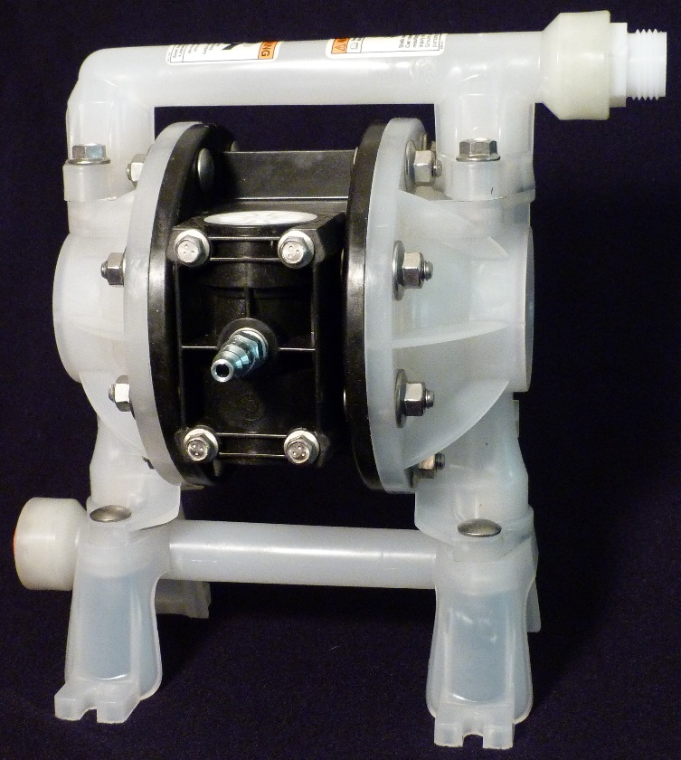
Klingstone Paths Pump

Additional Materials
Air Compressor | Minimum 18 gallon capacity, 8+ cfm rating
Air Compressor Hose | Standard ¼ inch connection
Standard Garden Hose | New, dry, 50 feet or less, 100 psi rating or higher, 5/8” thread
Uptake Lines | PVC construction, included with pump purchase
Application Wand | PVC construction, with ball valve attached, included with pump purchase
Safety Gear | See Safety Data Sheet (SDS)

Technical Information
Non-metallic, air operated, double diaphragm pump
Capable output of 1–14.4 gallons per minute
Powered by an air compressor
10-100 psi inlet/outlet pressure range
¼ inch male connector to air compressor hose
Standard 5/8” “garden hose thread”, the hose connects the pump to the application wand
½ inch PVC uptake lines

