Themes | Monday | Tuesday | Wednesday | Thursday | Friday
Hap[y Birthday Dr. Seuss |  |  |  |  | 1  Sing a Song 9:30 am  Tender Smiles Dental Program  Dr. Seuss Reading w/ Parents
Rainbows | 4  Stretch and Grow 11am | 5 | 6 | 7 | 8  Sing a Song 9:30am
Shamrock Fun | 11  Stretch and Grow 11am | 12 | 13 | 14 | 15  Sing a Song 9:30am
Spring | 18  Stretch and Grow 1 am | 19 | 20  Happy Spring | 21 | 22  Sing a Song 9:30am
Baby Animals  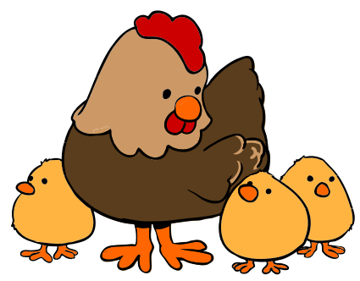 | 25  Stretch and Grow 11am | 26 | 27 | 28 | 29  Sing a Song 9:30am

