Date: _______________

PATIENT APPLICATION SURVEY
Name: _________________________________________________________ (Age) _______ Gender: M F
Home Address: __________________________________________________ Home Phone: ( ) _________________________
City, State, Zip: __________________________________________________ Work Phone: ( ) _________________________
Email Address: ___________________________________________________ Cell Phone: ( ) _________________________
Birth Date: ______ / ______ / _______ Marital Status: S M D W
Names of Children: ___________________________________________________________________ Ages: ____________________
Occupation: __________________________________________________ Employer Name: _______________________________
Spouse’s Name: __________________________ Work Phone: ( ) __________________ Cell Phone: ( ) ________________________
Spouse’s Employer: _________________________________________ Occupation: ____________________________________________
How were you referred to this office? __________________________________________________________________________________

PURPOSE OF THIS VISIT

Reason for this visit – Main Complaint:__________________________________________________________________________________
Is this purpose related to an auto accident / work injury? • Yes • No If so, when: _________________________________________
When did this condition begin? __________/_____/________ Did it begin: Gradual Sudden Progressive over time
What activities aggravate your symptoms? ____________________________________________________________________________
Is there anything, which has relieved your symptoms? • Yes • No Describe:__________________________________________________
Type of Pain: Sharp Dull Ache Burn Throb Spasm Numb Tingling Shooting
Does the Pain Radiate into your: ___Arm ___Leg ___Does not radiate Is this condition getting worse? • Yes • No
How often do you experience these symptoms throughout the day?: 100% 75% 50% 25% 10% Only with Activity
Does complaint(s) interfere with: __Work __Sleep __Hobbies __Daily Routine Explain: _____________________________________
Have you experienced this condition before? • Yes • No If so, please explain: _________________________________________________
Who have you seen for this? ______________________________________ What did they do? _________________________________
How did you respond? ____________________________________________________________________________________________

EXPERIENCE WITH CHIROPRACTIC

Have you seen a Chiropractor before? • Yes • No Who? __________________________________ When? _____________________
Reason for visits: ________________________________________________________________________________________________
Did you know posture determines your health? • Yes • No
Are you aware of any of your poor posture habits? • Yes • No
Explain: _________________________________________________________________________________________________________
Are you aware of any poor posture habits in your spouse or children? • Yes • No
Explain: _________________________________________________________________________________________________________

The most common postural weakness is Forward Head Syndrome (head and neck starting to bend forward and progressively moving downward weakening your whole body). Even less severe forms of this posture can cause many adverse effects on your overall health.

Have you ever been told or felt like you carry your head forward, noticed a rounding of your shoulders or a developing “hump” at the base of your neck? Yes No

Abnormal postural habits or distortions are the result of trauma or stress to the body that have misaligned the vertebrae in your spine. When these vertebrae are twisted from their normal position, they will cause stress to the spinal cord and the delicate nerves that pass between the vertebrae. These misalignments are called Subluxations (sub-lux-a-shuns). It has been extensively documented that subluxations, causing stress to your nerves, will weaken and distort the overall structure of your spine. This results in a weakened and distorted POSTURE. Postural distortions have many serious and adverse effects on your overall health. The most common and detrimental postural distortion is called Forward Head Syndrome (a “hunched forward” posture starting in the neck and progressively moving down your spine weakening the entire body).

HEALTH LIFESTYLE
Do you exercise? Yes No How often? 1X 2X 3X 4X 5X per week other: ______________________________________
What activities? Running Jogging Weight Training Cycling Yoga Pilates Swimming ________________
Do you smoke? Yes No How much? ________________________________________________________________________
Do you drink alcohol? Yes No How much / week? _______________________________________________________________
Do you drink coffee? Yes No How many cups / day? ____________________________________________________________
Do you take any supplements (i.e. vitamins, minerals, herbs)? __________________________________________________________

Please list any health conditions not mentioned: ___________________________________________________________________________

Please list any medications currently taking and their purpose : ________________________________________________________________

Please list all past surgeries: ____________________________________________________________________________________________

Please list all previous accidents and falls:

INSURANCE

Name of Primary Carrier: _________________________________________ Insured DOB: __________________

Name of Insured: _________________________________________________________________

Address: ___________________________________________________________________________________________________

Insurance ID # __________________________________________ Group # ______________________________

Name of Secondary Carrier: __________________________________________________ Insured DOB: __________________

Name of Insured: _________________________________________________________________

Address: ___________________________________________________________________________________________________

Insurance ID # __________________________________________ Group # ______________________________

__________________________ __________
Signature Date
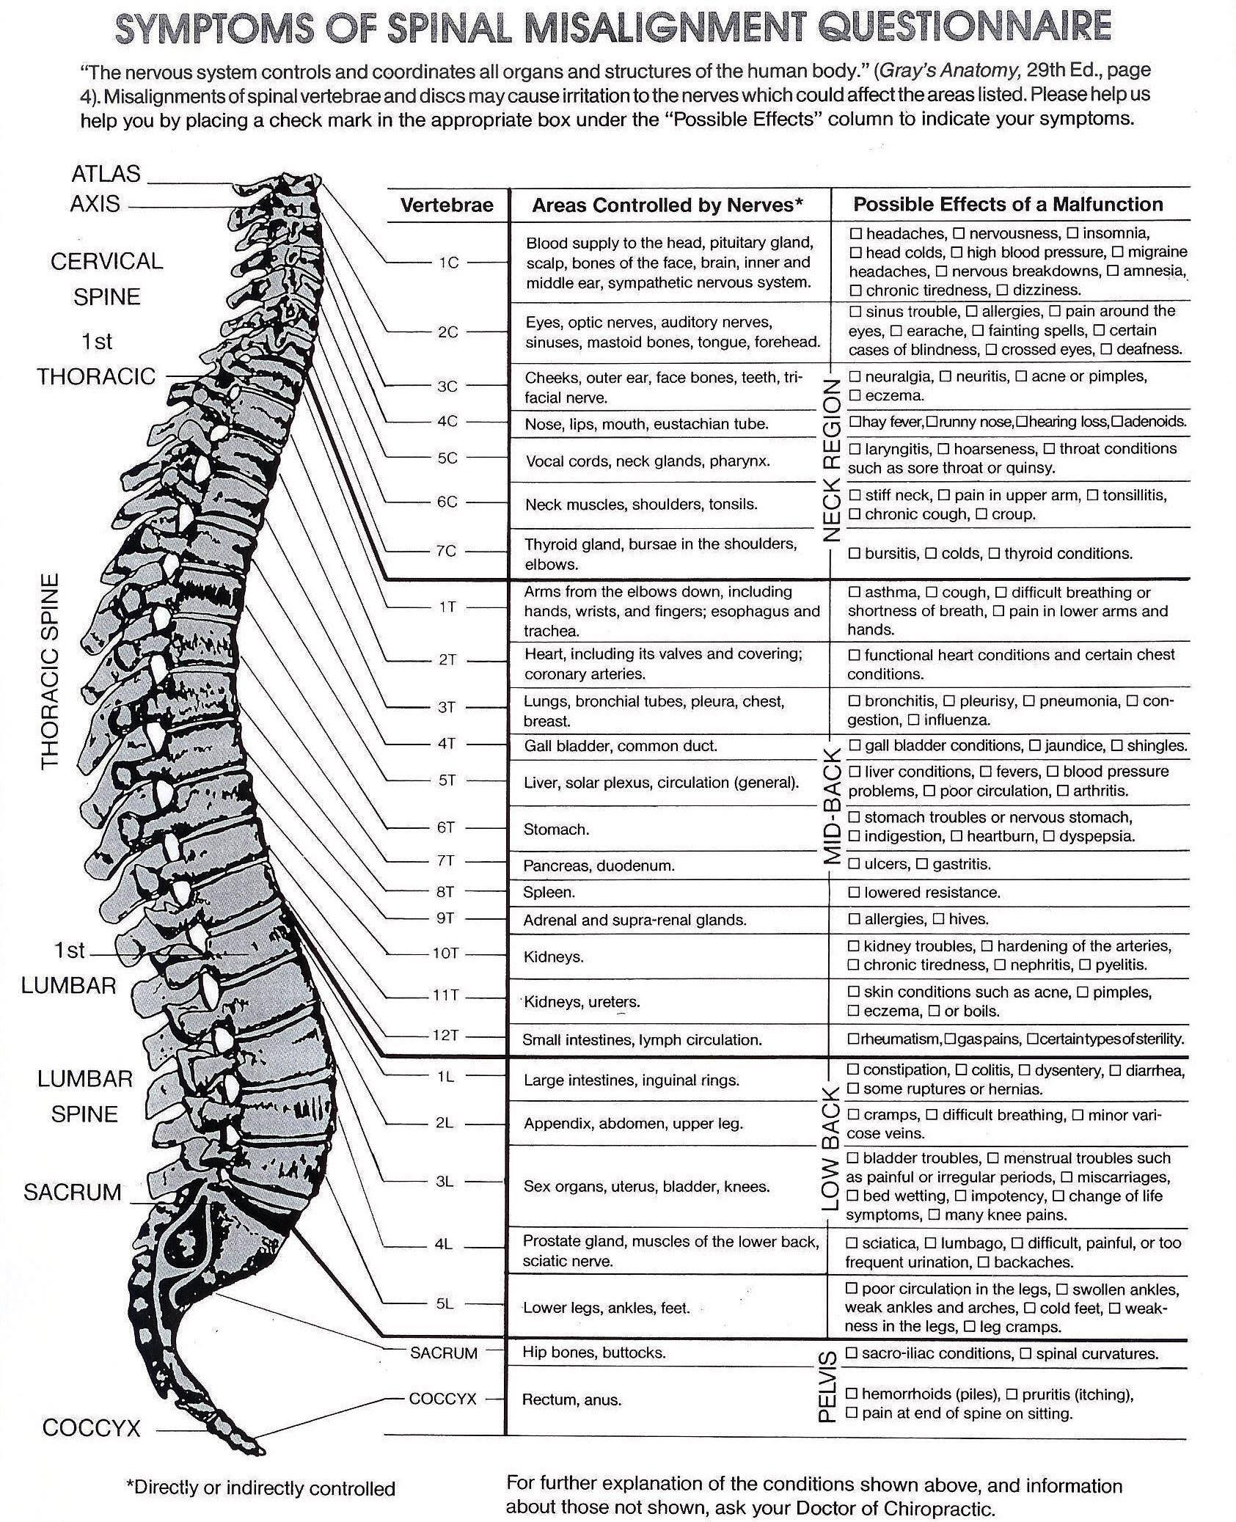

TERMS OF ACCEPTANCE

When a person seeks chiropractic health care and is accepted for such care, it is essential for both parties to be working towards the same objective. We have one main goal, to detect and correct/reduce the vertebral subluxation complex. It is important that each person understand both the objective and the method that will be used to attain this goal. This will prevent any confusion or disappointment.

Adjustment: An adjustment is the specific application of forces to facilitate the body’s correction of vertebral subluxation. Our chiropractic method is by specific adjustments of the spine.

Health: A state of optimal physical, mental and social well-being, not merely the absence of disease or infirmity.

Vertebral Subluxation: A misalignment of one or more of the 24 vertebra in the spinal column which causes alteration of nerve function and interference to the transmission of mental impulses, resulting in a lessening of the body’s innate ability to express it’s maximum health potential.

We do not offer to diagnose or treat a disease or condition other than vertebral subluxation. Regardless of what a disease is called, we do not offer to treat it. Nor do we offer advice regarding treatment prescribed by others. Our Only Practice Objective is to eliminate a major interference to the expression of the body’s innate wisdom and ability to heal. Our only method is specific adjusting to correct vertebral subluxations. NOTE: It is understood and agreed the amount paid to Revelation Chiropractic for x-ray, is for examination only and the x-rays will remain the property of this office, being on file where they may be seen at any time while a patient of this office.

CONSENT TO CARE

I do hereby authorize the doctors of Revelation Chiropractic to administer such care that is necessary for my particular case. This care may include consultation, examination, spinal adjustments and other chiropractic procedures, including various modes of physical therapy and diagnostic x-rays or any other procedure that is advisable, and necessary for my health care.

Furthermore, I authorize and agree to allow Revelation Chiropractic to work with my spine through the use of spinal adjustments and rehabilitative exercises for the sole purpose of postural and structural restoration to allow for normal biomechanical motion and neurological function.

I have had an opportunity to discuss with the doctor of chiropractic and/or with other office or clinic personnel the nature and purpose of chiropractic adjustments and other procedures related to my health care. I understand that I am responsible for all fees incurred for the services provided, and agree to ensure full payment of all charges. I further understand that a fee for services rendered will be charged and that I am responsible for this fee whether results are obtained or not.

I also clearly understand that if I do not follow the Doctors specific recommendations at this clinic that I will not receive the full benefit from the programs offered, and that if I terminate my care prematurely that all fees incurred will be due and payable at that time. I authorize the assignment of all insurance benefits be directed to the Doctor for all services rendered. I also understand any sum of money paid under assignment by any insurance company shall be credited to my account, and I shall be personally liable for any and all of the unpaid balance to the doctor.

__________________________________ __________
Signature Date

I, ________________ being the parent of legal guardian of _________________ have read and fully understand the above terms of acceptance and hereby grant permission for my child to receive chiropractic care.

___________________________________ ___________
Signature Date

Consent to X-ray

I hereby grant Revelation Chiropractic, LLC permission to perform an x-ray evaluation if needed. I understand that x-rays are being performed to locate vertebral subluxation, and not to diagnose or treat any other disease or condition. This is to certify that to the best of my knowledge I am not pregnant and the above doctor and his associates have my permission to perform an x-ray evaluation.

Date of last menstrual cycle (if applicable): _________________________

____________________________________ ___________
Signature Date

PAYMENT CARD

Office Visit/Consultation |  | Testimonial Given__________________________
Evaluation Card |  | ___________________________________________________________
Car Accident/Workmans Comp
Screening: $20 $40 $60 |  | Notes______________________________________
Special/Other________________ |  | ____________________________________________
 |  | ____________________________________________
$75 NPM: Adult Exam |  | ____________________________________________
$50 NPM: Child Exam
$50 Pastor's Initial Exam
 |  | Charge _______________
$40 X-Ray 1 |  | Payment Collected _______________
$50 Cervical X-Ray 2 |  | CA Initials _______________
$50 Thoracic X-Ray 2
$50 Lumbar X-Ray |  | PDR: T(6:00)__________
 |  | Other__________
$35 Adult Adjustment
$30 Child/Student Adjustment

