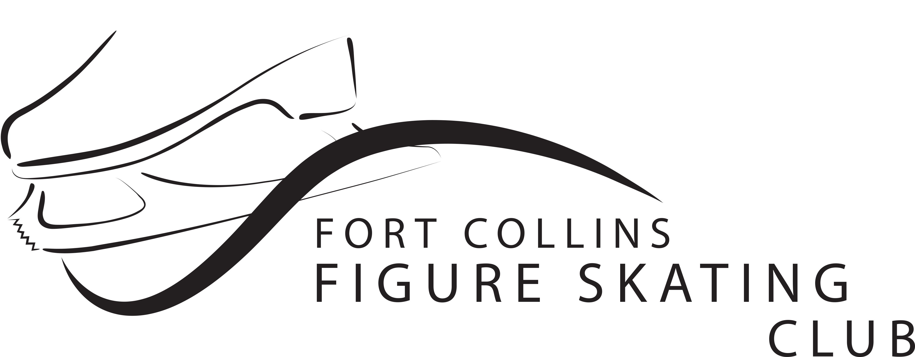
COVID-19 FCFSC Group event Symptom Checker
Please provide this information in order to participate in a group activity held by the FCFSC. In addition to following State mandated mask and social distancing orders, the FCFSC requests that you provide this symptom check form to determine your ability to participate in a group activity sponsored by the FCFSC. If you answer “yes” to any of the below questions or you have a temperature ≥100°F we ask that you do not participate in FCFSC group activities for 14 days or until you receive a negative test result. Remember that when you join the FCFSC you have agreed to adhere to an ethical standard in the club’s code of conduct. We all want to keep the ice open and safe for all members. If you have any questions, please contact fcfigureskating@gmail.com
Please fill in the Information below:
Skater name: ___________________________________________________________________
Date: _________________________
Temperature: __________________
In the past 2 weeks has the skater TESTED POSITIVE for COVID-19? (Circle one) YES NO
Has the skater been tested for COVID-19 and are waiting for a result? (Circle one) YES NO
Has anyone in the skater’s household tested positive for COVID-19 or waiting for test results?(Circle one) YES NO
Is the skater experiencing any of the following symptoms (unrelated to a pre-existing conditions or
other known conditions diagnosed by a doctor, such as an infection or season allergies? (Circle one) YES NO

Fever, chills, body or muscle aches
Sore Throat or cough
Nausea, Vomiting or Diarrhea
Shortness of breath or difficulty breathing
Loss of taste or smell

I certify that the above information is true:

Print name

Signature of skater or of parent or guardian if under the age of 18

