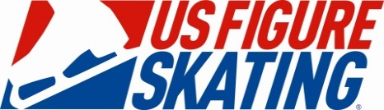
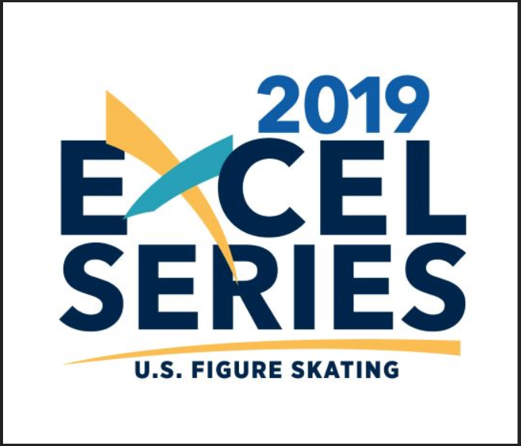
Sanctioned by US Figure Skating

FORT COLLINS CLASSIC 2019
April 4-7, 2019
FORT COLLINS FIGURE SKATING CLUB
EDORA POOL AND ICE CENTER
1801 RIVERSIDE DRIVE
FORT COLLINS, CO 80525
Chief Referee: Hannah Katz
Chief Accountant: Sheldrin Zhu
Attended by ISU, International, National, and Competition-Level USFSA officials.
Hosted Events: Compete USA Solo Free Skate, Pairs, Compulsory, Showcase Solo and Duet Events.
Pre-Preliminary-Senior Well-Balanced, Excel, Excel Plus, Adult, and Compete USA Solo Free skate events. Pairs Compete USA through Senior levels. Spins Compete USA through Senior Level. Jumps Compete USA through Senior level. Compulsory Compete USA through Senior level. Showcase Solo and Duet events Compete USA, Adult, and Pre-Preliminary to Senior Level. Mini Ensembles, Ensembles, and Synchronized Exhibitions.
IJS Mini System will be used for Preliminary through Senior Level Well Balanced Free Skates. All Excel Plus Levels and Intermediate through Senior Excel Levels. Preliminary to Senior Well Balanced Spins and Jumps.
Entries due March 4th, 2019-Online registration only!
($10 early bird discount if you register by 11:59 pm MST Feb 10, 2019)
For further information please contact the competition chair Kelly Cann: kelly.cann79@gmail.com
Fort Collins Classic will be conducted in accordance with the rules and regulations of U.S. Figure Skating, as set forth in the current rulebook, as well as any pertinent updates which have been posted on the U.S. Figure Skating website.

This competition is open to all eligible, restricted, reinstated or readmitted persons as defined by the Eligibility Rules, and is a currently registered member of a U.S. Figure Skating member club, a collegiate club or an individual member in accordance with the current rulebook. Please refer to the current rulebook for non-U.S. Citizens.

SERIES INFORMATION: The 2019 Fort Collins Classic has been approved by U.S. Figure Skating as part of the 2019 Excel Series as well as the 2019 Skate Colorado Compete USA Series.

Excel Series
The Fort Collins Classic competition is a designated Excel Series competition for the 2019 Excel Series. As an Excel Series event, skaters entered in the Series at eligible levels will earn points for their placement here in order to qualify for the National Festival to be held in Coral Springs, Florida, June 7 – 9, 2019. Skaters must registered for the Excel Series prior to competing at designated competition or by March 1; registration is available by clicking here and additional information is available on U.S. Figure Skating’s Excel webpage. For any questions related to the Excel Series, please contactExcelSeries@usfigureskating.org .

ELIGIBILITY /TEST LEVEL:
Test Level: Competition level is the highest test passed as of the entry deadline in the discipline the skater is entering. Entrants may skate one level above that for which they qualify, but they may not skate down in any event.
Age restrictions/requirements: Singles free skate events (Well Balanced Program) have the following requirements.
Juvenile: Girls – 12 years of age or younger; Boys – 13 years of age or younger
Open Juvenile: Girls – 13 years of age or older; Boys – 14 years of age or older
Intermediate must be under the age of 18
Adults must be 21 years of age or older.
ENTRIES:
Entries must be entered online by 11:59 pm MST on March 4, 2019. Online registration with secure credit card payment at www.fortcollinsfsc.org. Late entries or changes to your entry after entry deadline will be accepted only at the discretion of the Chief Referee and there will be an assessed $25.00 fee.
EARLY BIRD DISCOUNT: Entries registered by 11:59 pm MST February 10, 2019 will receive a $10 early bird discount.
ENTRY FEES:
Event Type | Entry Fee | Comments
First IJS Event | $115.00
Additional IJS Event | $50.00
First 6.0 Event | $100.00 | $50/skater for Artistic Duet
Additional 6.0 Events | $45.00 | $20/skater for Artistic Duet
Pairs as only Event | $50.00 | Per Skater
Pairs as second Event* | $25.00 | Per Skater
First Compete USA Event | $60.00
Additional Compete USA Event | $30.00
Synchronized Teams, Group Ensembles, and Mini Ens. | $100.00 + $5/skater
Special Olympics First Event | $40
Special Olympics 2nd Event | $25
EARLY BIRD DISCOUNT | -$10 | Registered by February 10th
Late fee/change fee | $25 | Late registration or change after March 4th.
Late PPC/Music Upload Fee | $15 | PPC and/or music not uploaded by March 4th
*Please note that pairs may not be taken as your first event unless it is the only event you are entering. Short and long programs for single and pairs are being offered as separate events.
Notification of competition and practice ice times, schedules and announcements will be sent to your email through EntryEeze. Listing a valid email address when you register online is required.

Competition information and updates can be found at www.fortcollinsfsc.org.

TENATIVE SCHEDULE: The event schedule will be set by the Chief Referee in cooperation with the LOC after the close of entries and is subject to change. A tentative schedule will be listed on our website after the beginning of the year. This schedule is provided for planning purposes only and should not be considered final. The final schedule will be published approximately two weeks before competition on Entryeeze.
REFUND POLICY: Entry fees will not be refunded after March 4, 2019 unless no competition exists or the event is canceled. There will be no refunds for medical withdrawals. The online processing fees are not refundable. Checks returned for non-sufficient funds and contested credit card charges will be issued a $25.00 fee. Payment of the fee will be required before the skater is allowed to participate in practice ice or events.
FACILITIES: The competition will be held at Edora Pool and Ice Center (EPIC), 1801 Riverside Ave. Fort Collins, CO 80525. (970) 221-6683. https://www.fcgov.com/recreation/epic.php1
The facility has two NHL size ice surfaces measuring 85’ by 200’ which consist of the Blue rink and the Green rink. There is spectator seating on both rinks. The Green rink can be cold so remember to dress warm. There are vending machines on site and there will be locker rooms and warm up areas available for all competitors.

MUSIC: Music must be submitted electronically via the online registration system by the music deadline of March 25, 2019. A back up CD should be readily available at the competition in case something happens to your music rink side. CD’s will only be accepted at registration if the electronic file could not be downloaded by the music staff. You will be prompted to provide a cd at registration if this is the case. The LOC will accept no responsibility for damage or loss.

LIABILITY: U.S. Figure Skating, Fort Collins Figure Skating Club and Edora Pool and Ice Center (EPIC) accept no responsibility for injury or damage sustained by any participant in this competition. This is in accordance with Rule 1600 of the official U.S. Figure Skating Rulebook.

JUDGING SYSTEM: ****2019-2020 RULES WILL BE USED

The International Judging System (IJS) will be used for the following events:
- Well Balanced Program Free Skate events- Preliminary – Senior
- Excel Free Skate Events: Preliminary Plus, Pre-Juvenile Plus, Juvenile Plus, Intermediate, Novice, Junior, Senior
- Short Program Events, Open Juv, Juvenile – Senior
- Pairs Free Skate events, Juvenile – Senior
- Pairs Short Program events, Intermediate – Senior
- Adult Gold/Championship Gold, Masters Intermediate – Senior
- Spins –Preliminary – Senior
- Jumps—Preliminary-Senior

IJS Ltd Preliminary through Pre-Juvenile events will be called according to the standard rules of IJS (see TN 201)
Spins will be limited to a maximum of level 1 in BOTH Freeskate and in Spins events

IJS Preliminary through Pre-Juvenile events will be called according to the standard rules of IJS.
-Step sequences will be called as ChSt.
-Spins will be limited to a maximum of level 2.
-The ½ loop jump is a listed jump per USFSA Rulebook and Technical notification 167
-Free skate events have 3 components: Skating skills and transitions, performance and execution and choreography and interpretation.

All competitors skating in these events need to submit the Planned Program Content (PPC)online through EntryEeze. The deadline to submit the PPC is March 25, 2019 at 11:59 pm. There will be a $15 late fee PRIOR TO SKATING for skaters who do not turn in their PPC.

The 6.0 Majority Judging System will be used for:
Well Balanced Program Free Skate events, No Test, Pre-Preliminary & Ltd Pre-Preliminary
Excel Beginner, High Beginner, Pre-Preliminary, Preliminary, Pre-Juvenile, and Juvenile

Compete USA – Snowplow Sam through Basic 8 and Pre-Free Skate through Free Skate 6.
Specialty Singles Events (Spins Beginner – Pre-Preliminary, Jumps Beginner-Pre Preliminary, Compulsory Moves,
Showcase solos, duets, and ensembles
Adult Pre-Bronze – Silver

REGISTRATION: Registration will begin 1 hour before the first event and will remain open through the last event. The registration area will be located in the skate rental area on the north side of the EPIC lobby. Please register promptly upon your arrival to the rink and no later than 1 hour before your first event.

LOCKER ROOMS AND CHANGING AREAS: This event will be following the Locker Rooms and Changing Area policy included in the SafeSport Handbook. There will be a designated locker room for parents with children 11 and under and locker rooms available for other participants. See registration desk for further info.

PRACTICE ICE: Practice ice will begin on Thursday, April 4, 2019. Practice ice will be offered for all Free Skate, Short Program, Compulsory, and Artistic Events. There is a maximum of 2 Practice Ice sessions per skater, per eligible event (Max of 1 per synchronized team). Practice Ice will be 30 minutes.
Compete USA (Basic Skills) Practice Ice is 20 minutes in length. Eligible events are Free Skate, Compulsory, Pairs, and Artistic Events. Skater music will not be played. Compete USA PI will begin on April 6, 2019

Pre-Event Warm up is 20 minutes in length and will take place prior to and on the same day as the event being skated. Warm ups will be available for Short Programs and Free Skate (Juv and above).

PRACTICE ICE FEES
Practice ice - 30 min | On or before March 4:  $15 | March 5- April 3rd:  $18 | Start of competition:  $20
Warm up ice - 20 min | On or before March 4:  $12 | March 5th - April 3rd:  $14 | Start of competition:  $15
Compete USA ice –  15 min | On or before March 4:  $6 | March 5th - April 3rd:  $8 | Start of competition:  $10
Synchro ice - 30 min | On/before March 4th:  $100 per team | N/A | N/A

Additional practice ice sales will be sold on-line for $18 per session ($8 basic skills) after the registration deadline. Additional practice ice will be available for purchase during the competition and will cost $20 ($9 basic skills) at the practice ice desk.

Practice ice may or may not take place on the competition ice surfa

ce. There is NO “official practice ice” and NO MUSIC will be played on any practice ice or warm up session. Assigned practice ice is non-refundable. If you have questions about practice ice, please contact Kelly Cann- Kelly.cann79@gmail.com

Synchronized skating exclusive practice ice will be in 30 minute increments at $100.00

Props are not allowed on practice ice.

We reserve the right to cancel or change any practice ice session.

Practice ice will be organized by skater when possible. Practice ice will be selected by the skater. After the close of entries, you will receive an email from the LOC through EntryEeze letting you know when practice ice selection is selection is available. Practice ice is not refundable after the close of entries on March 4, 2019.

If you have issues with practice ice the day the competition starts or at the competition, please do not call or email. Please see the practice ice table.

PHOTOGRAPHY/VIDEOGRAPHY: TBD

AWARDS: Presentation of awards will immediately follow the posting of results. Awards will be given to 1-4th place skaters with the exception of Compete USA (Basic Skills) which an award will be given to 1-6th place.

OFFICIAL NOTICES: An official bulletin board will be maintained next to the registration desk. It is the responsibility of each competitor, parent and coach to check the bulletin board frequently for any schedule changes and/or additional information. Skaters are requested to arrive 45 minutes to 1 hour prior to the scheduled time of their event. A tentative schedule of events will be posted prior to the competition.

INFORMATION REGARDING COACHES:
U.S. Figure Skating Rule MR 5.11 Coach Registration
In order to be granted access to work within U.S. Figure Skating sanctioned activities, each coach must complete the following requirements on an annual basis by July 1:
A. Must be a current full member of U.S. Figure Skating - either through a member club or as an individual member;
B. Must complete the coach registration process through the U.S. Figure Skating Members Only site, submit proper payment for the annual registration fee of $30 and, if 18 years of age or older, successfully pass the background screen.
C. Must complete the appropriate CER courses (A, B, C or D) depending on the highest level of students being coached as of July 1. See rule MR 5.12.
D. Must submit proof of current general liability insurance with limits of $1 million per occurrence/$5 million aggregate.

For Learn to Skate USA ONLY coaches - Any person, 18 and older, instructing a Learn to Skate USA Program must have successfully passed the annual background screen, be registered as a Learn to Skate USA instructor and completed the Learn to Skate USA Instructor Certification or U.S. Figure Skating Coach Compliance.

The local organizing committee/club will have a list of compliant coaches who are cleared for a credential at the competition. Coaches will need to check in at the event registration desk and show a government issued photo I.D. to receive a credential.

If a coach cannot provide a photo I.D. and is not on the list or cannot produce the necessary documents, he or she will not be allowed a credential – no exceptions. We strongly urge all coaches to have their cards with them. Non-credentialed coaches will not be permitted in the designated coaching area at rink side during events including practice sessions. Coaching at U.S. Figure Skating events without proper registration is an ethics violation which is reported to U.S. Figure Skating and PSA.

For more information regarding Coach Compliance, please refer to:
http://usfsa.org/story?id=84159

CONTACT INFO: Email preferred. No phone calls past 9 pm MST.

Chief Referee | Hannah Katz | hannahekatz@gmail.com
Chair | Kelly Cann | Kelly.cann79@gmail.com | (970) 237-9842
Co-Chair | Amy Aspelund | aspelua@yahoo.com
Practice Ice | Kelly Cann
Programs & Ads | Marci Pilon | mpilon@rocketmail.com | (970) 980-9407
Vendor | Carol Hartman | covakey@comcast.net | (970) 290-3809

ADDITIONAL INFORMATION:

ADMISSIONS: This competition is open to the general public for viewing at no charge. Please, no flash photography or videotaping.

CRITIQUES: Will be offer for all IJS Short and Free Skate events only. They will be $10 per critique. The critiques will be based on officials’ availability. Please purchase your critique online through EntryEeze. When purchasing the critique on EntryEeze please specify both the level AND event.

HOTELS: Please see the FCFSC website for official hotel information. www.fortcollinsfsc.org.

HOSPITALITY: There will be hospitality available for both officials and coaches. Coaches hospitality will be located in the Pro’s room located in the lobby of the green rink.

ADVERTISING: If you are interested in placing an ad in the competition program for your skater, your club, your business or your upcoming competition, please see the following page.

Fort Collins Classic
Competition Program-Advertising Form
DEADLINE: March 18, 2019

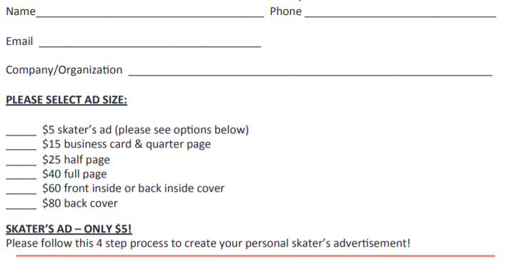
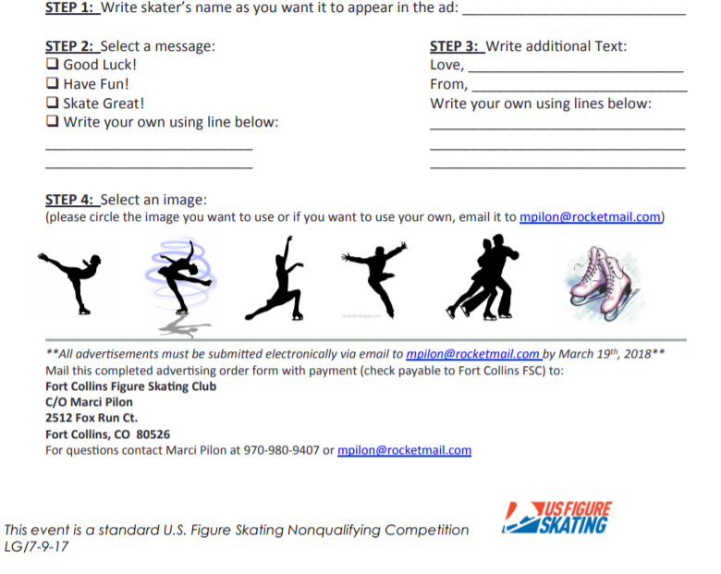

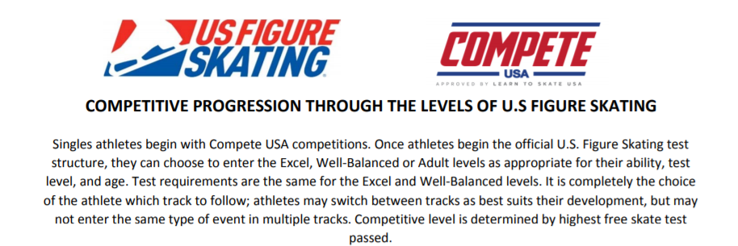
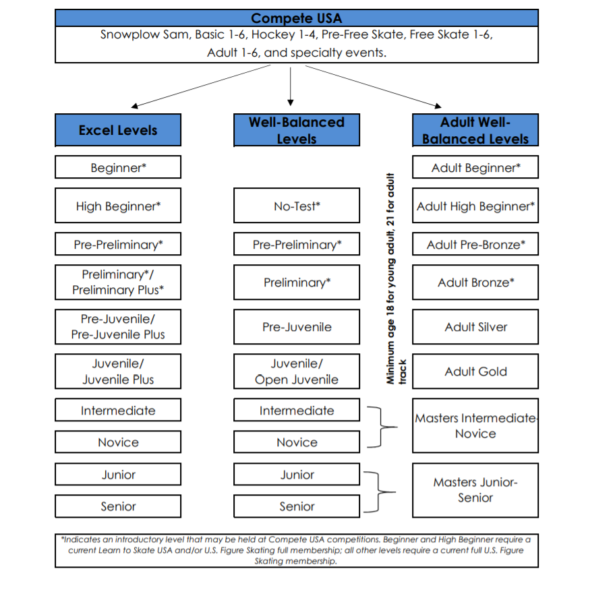

U.S. Figure Skating Nonqualifying Competitions
FREESKATE EVENTS: Well-Balanced No Test Through Senior
Skaters may enter EITHER a Well-Balanced Free Skate event or a Test Track Free Skate but NOT both. Skaters will skate to the music of their choice.
The following charts highlight the elements in each program. They are not meant to replace the reading of the rules in the current version of the U.S.
Figure Skating rulebook. Should these charts disagree with the current U.S. Figure Skating Rulebook in any aspect, the rulebook takes precedence.
In 6.0 judged events, the following deductions will be taken:
-0.1 from each mark for each technical element included that is not permitted in the event description
-0.2 from the technical mark for each extra element included
-0.1 from the technical mark for any spin that is less than the required minimum revolutions
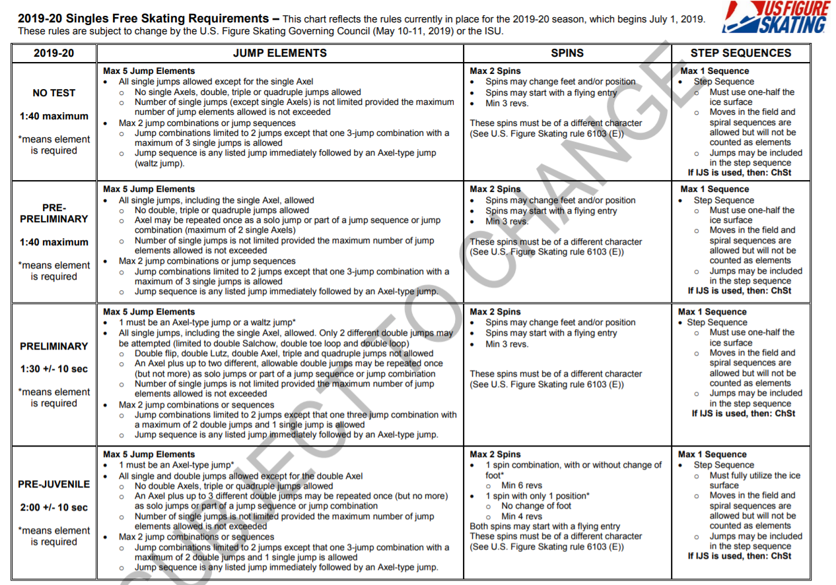

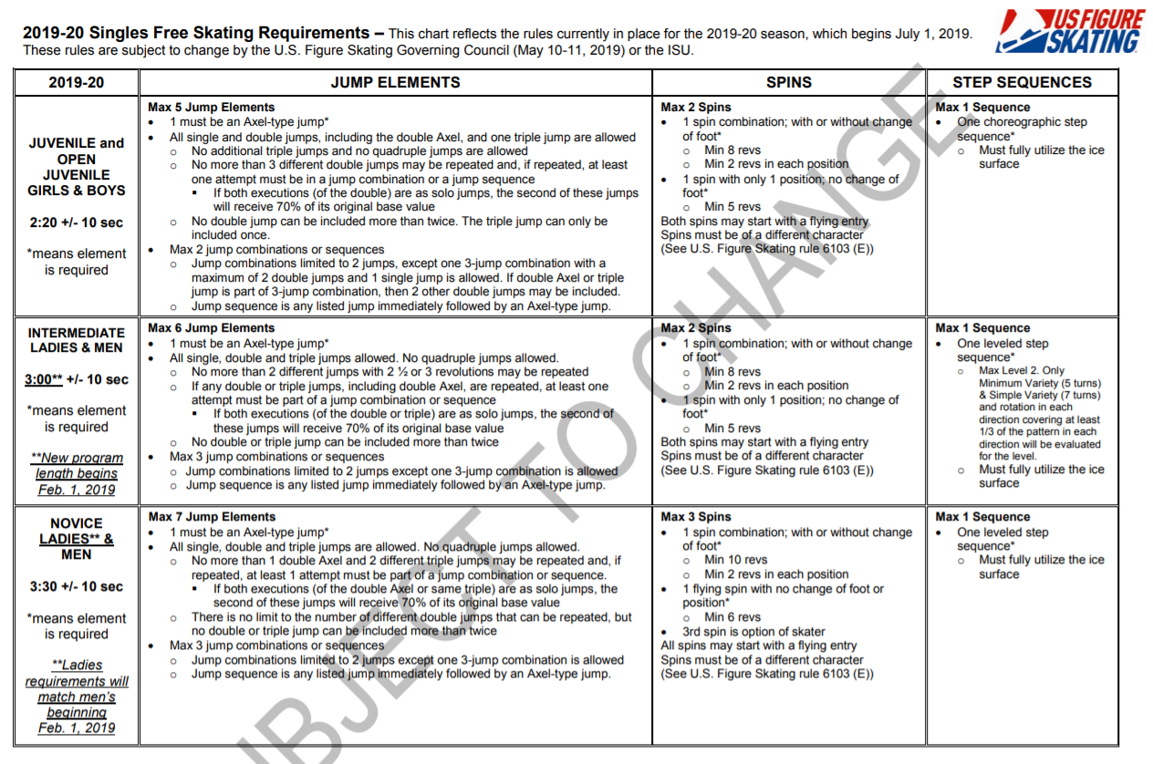

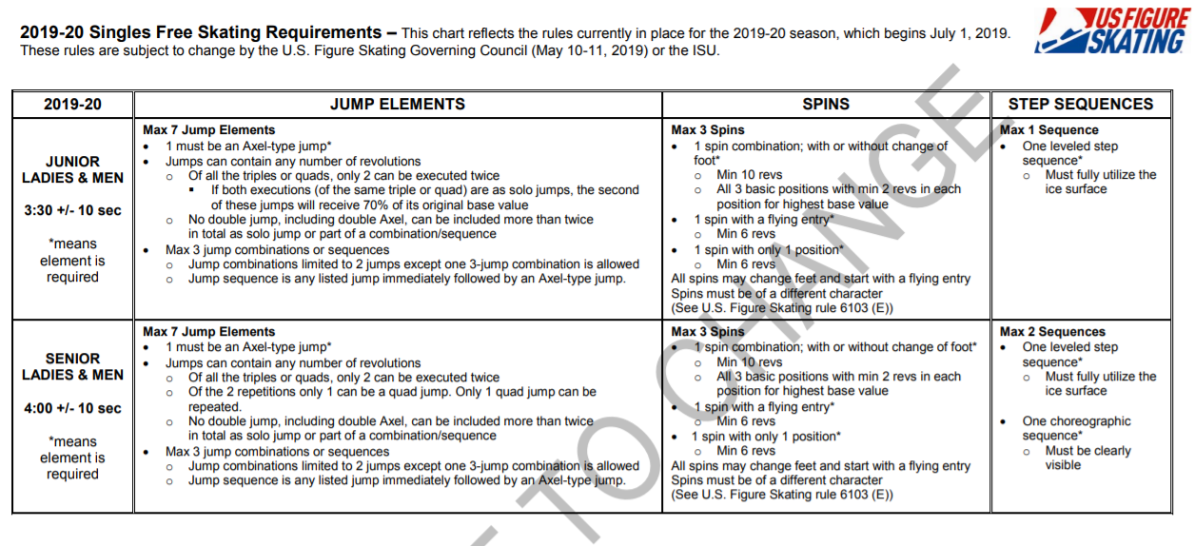

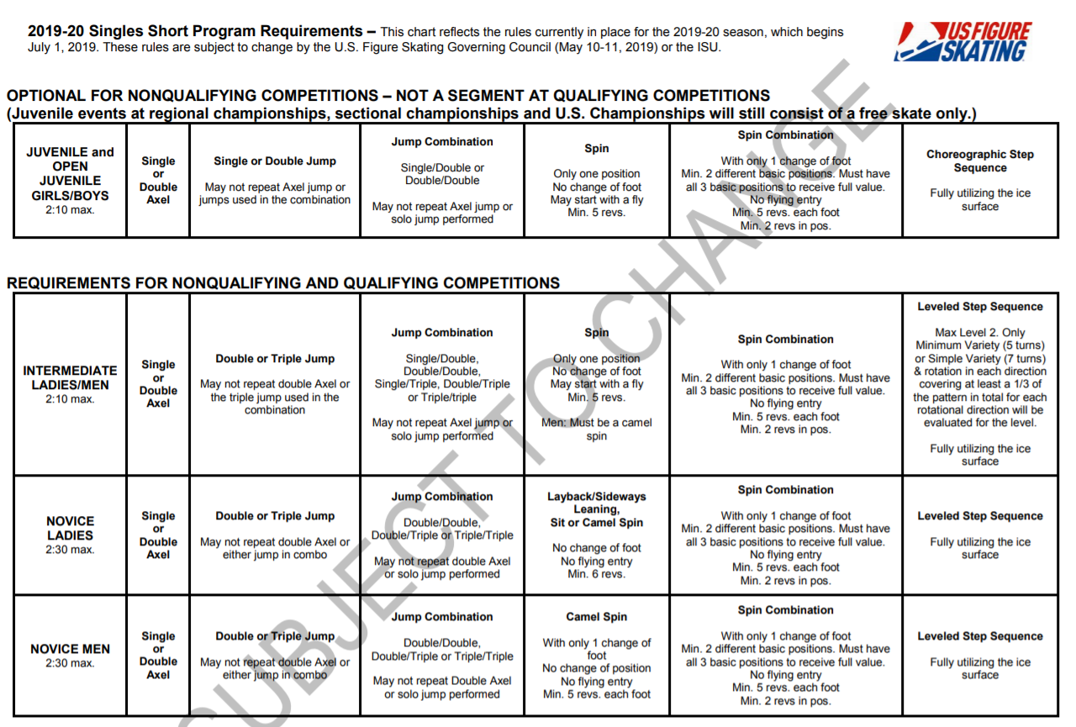

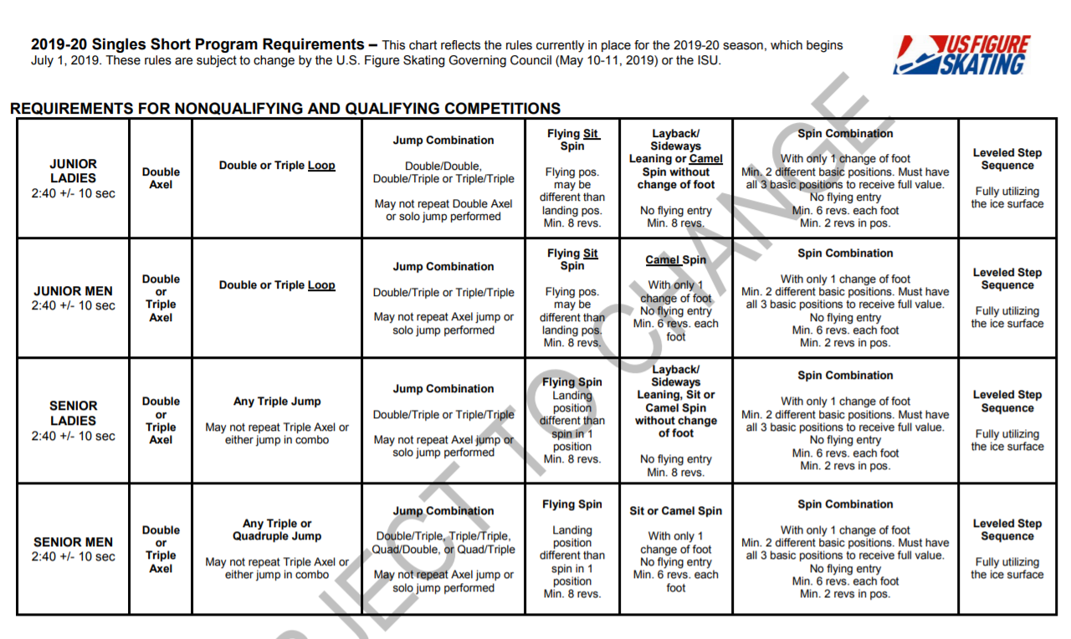

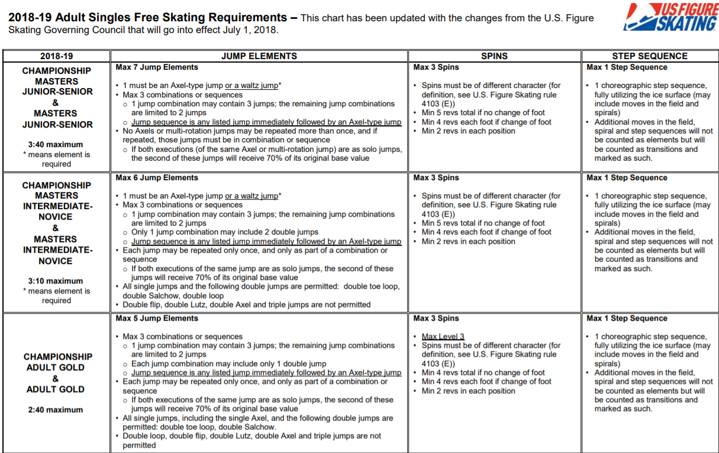
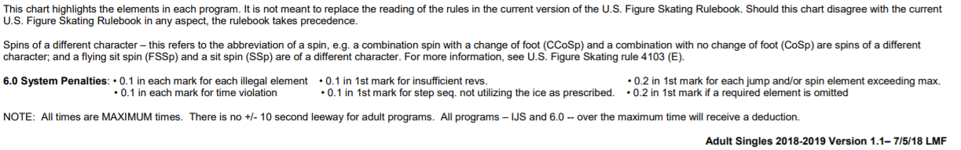

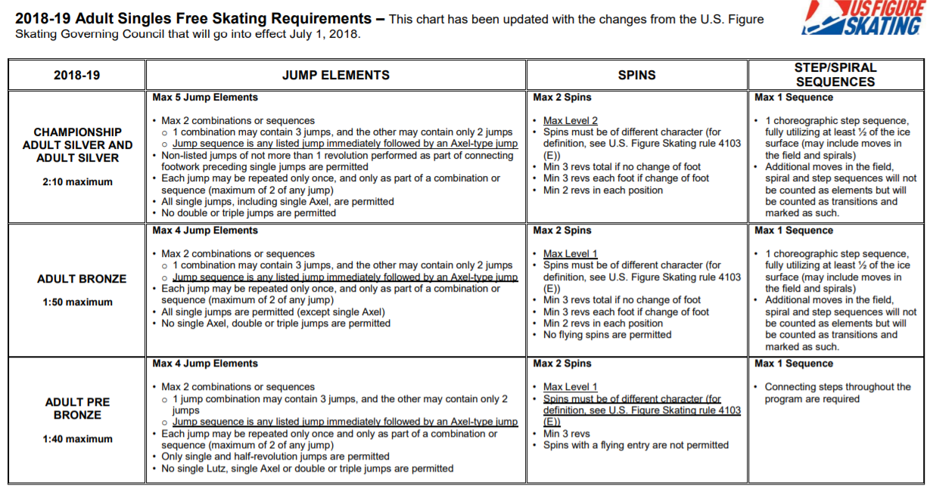
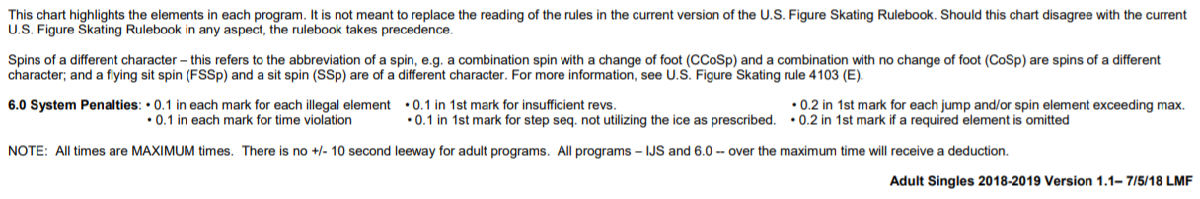

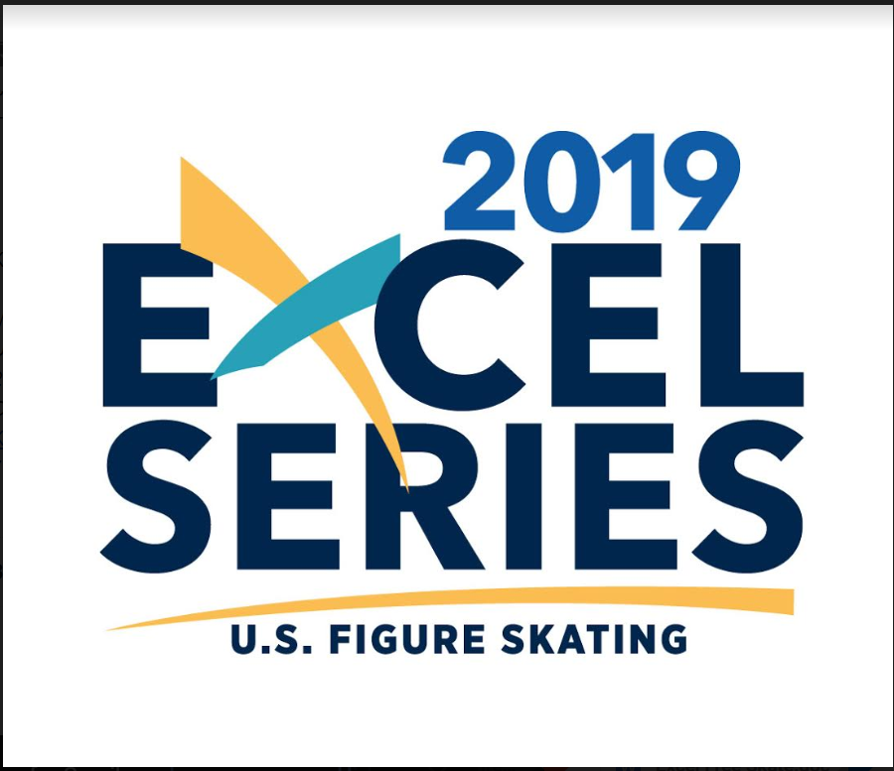

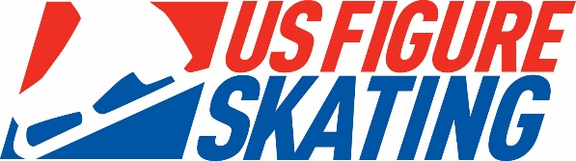

EVENT: 2018-2019 Excel Free Skate
General event parameters:
- Skaters may not enter both a Well-Balanced Free Skate event and an Excel Free Skate event at the same non-qualifying competition.
- Skaters will skate to the music of their choice. Vocal music is permitted at all levels.
- Level will be determined by the highest Free Skate test passed. Skaters may compete at the highest level they have passed, or “skate up” to one level higher.
- https://fs12.formsite.com/USFSAIT/images/2019_Excel_Series_Handbook.pdf
http://www.usfigureskating.org/content/Excel%20Free%20Skate%20Technical%20Information.pdf
Excel events may be run as either 6.0 or IJS subject to the individual competition announcement. Events will be run in accordance with the Excel Technical Handbook on the Excel Program webpage, regardless of which judging system is used.

** Intermediate and Novice Program lengths will change February 1, 2019, to align with the Well-Balanced program length changes.

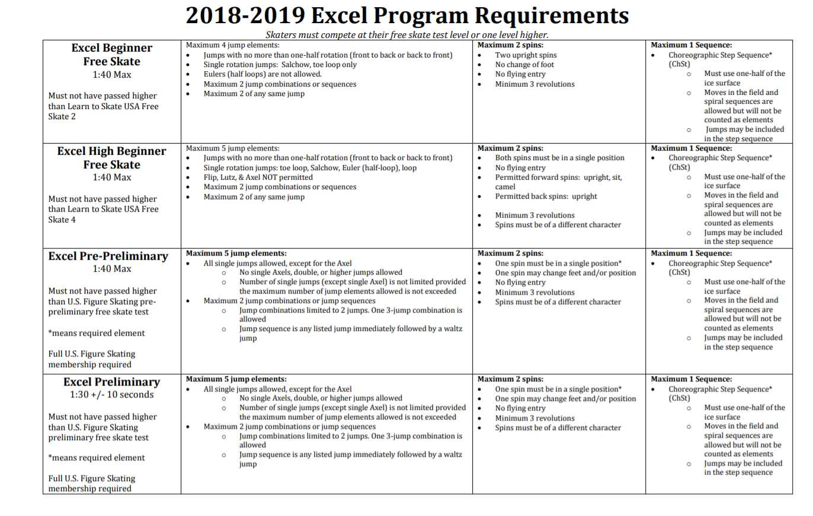

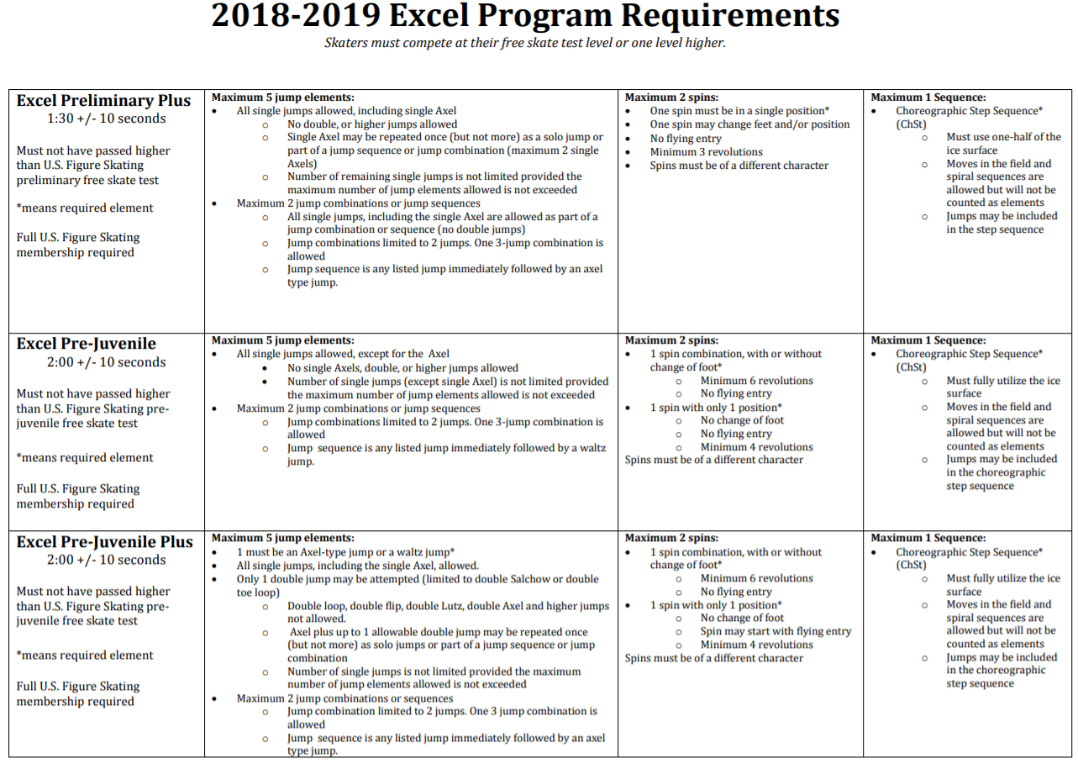

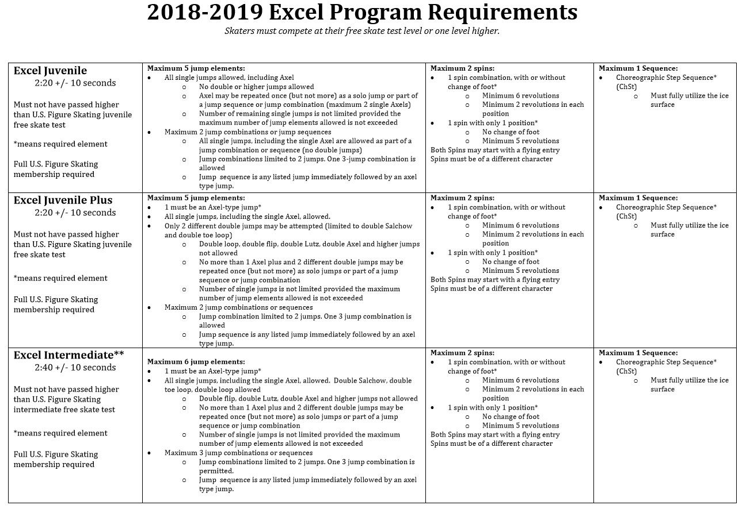
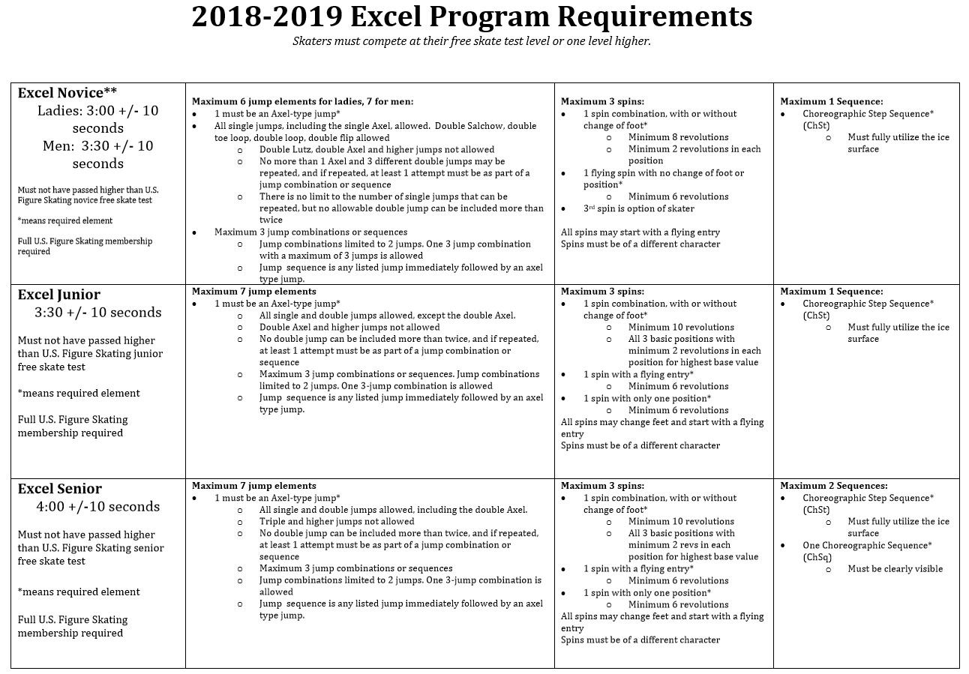

PAIRS FREE SKATING EVENTS

Pairs events will be conducted in accordance with the U.S. Figure Skating rulebook. Athletes and coaches are responsible for going to the U.S. Figure Skating rulebook for rules, program length, etc.

-Pre-juvenile - Senior https://www.usfigureskating.org/content/2019-20%20Pairs%20FS%20Chart.pdf

PAIRS SHORT PROGRAM EVENTS
Pairs events will be conducted in accordance with the U.S. Figure Skating rulebook. Athletes and coaches are responsible for going to the U.S. Figure Skating rulebook for rules, program length, etc.

-Novice through Senior: https://www.usfigureskating.org/content/2019-20%20Pairs%20SP%20Chart.pdf

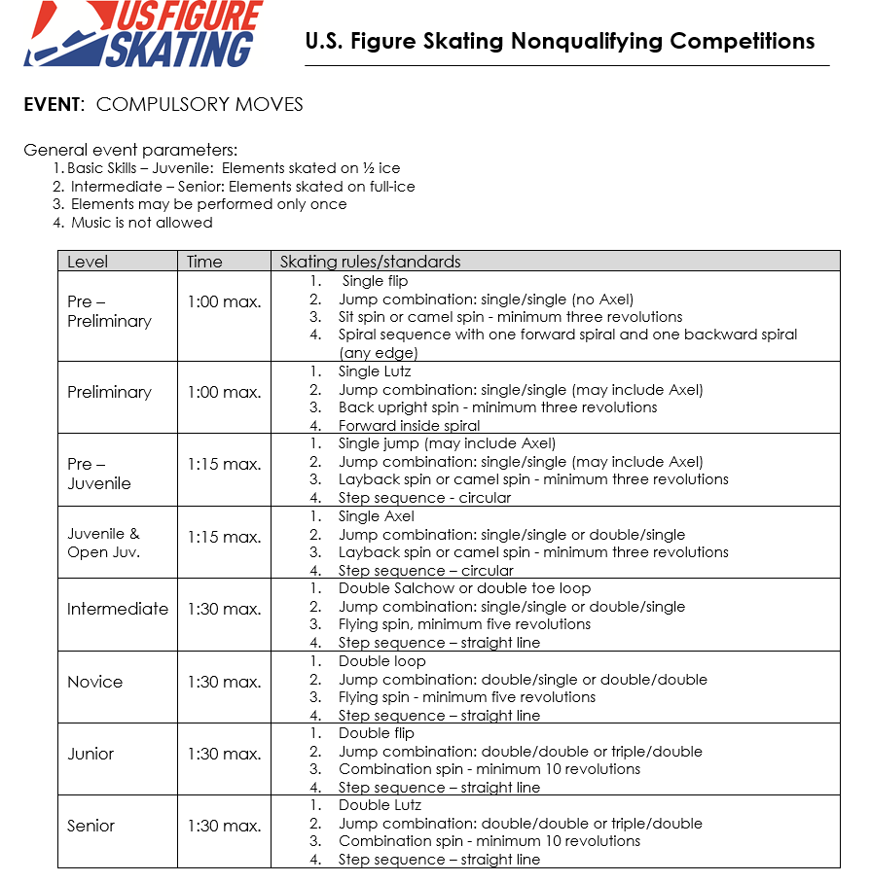
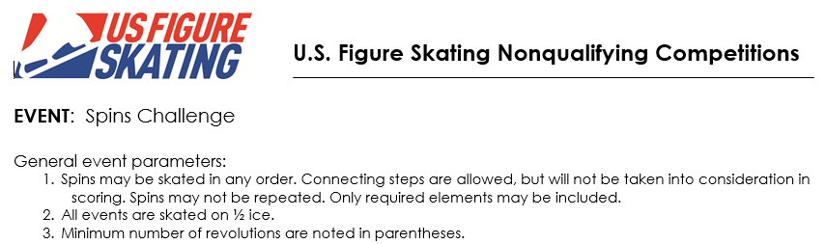
IJS SYSTEM WILL BE USED FOR Preliminary to Senior. The 6.0 System will be used for Beginner through Pre-Preliminary.
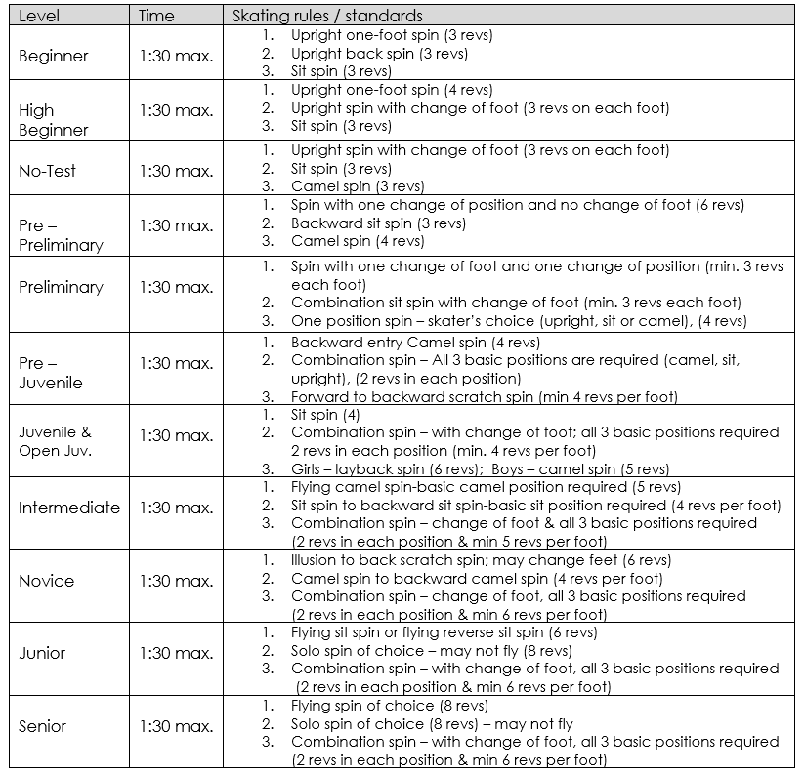

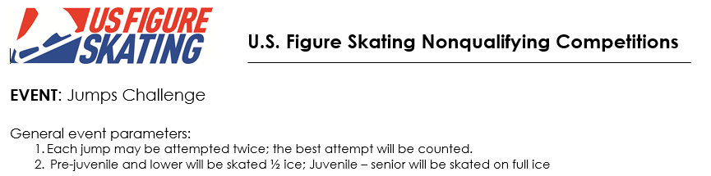
IJS SYSTEM WILL BE USED FOR Preliminary to Senior. The 6.0 System will be used for Beginner through Pre-Preliminary.
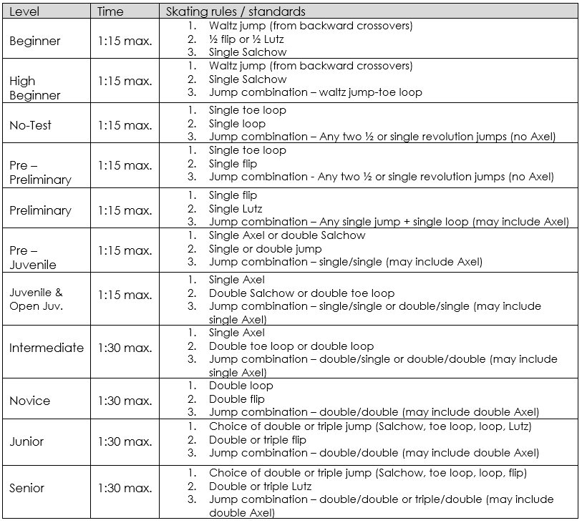

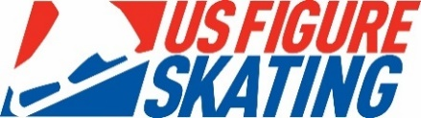
U.S. Figure Skating Nonqualifying Competitions

EVENT: Showcase Events – Light Entertainment Events

Format:
- Showcase program that should express a carefree concept or storyline designed to uplift and entertain the audience through related skating movements, gestures and physical actions.
- Props and scenery are permitted.

General event parameters:
- Level will be determined by the highest free skate or dance (solo or partnered) test passed. Skaters may compete at the highest level they have passed, or skate up to one level higher.
- The determination of level will be based upon test requirement at the entry deadline.
- Current guidelines and procedures for nonqualifying showcase competitions can be found at www.usfigureskating.org, under “Programs” on the National Showcase page.

EVENT: Showcase Events – Dramatic Entertainment Events

Format:
- Programs should express intense emotional connection and investment in the music, choreography and theme concept through related skating movements, gestures, and physical actions. The entire gamut of emotions may be expressed including intense joy and/or introspectiveness.
- Props and scenery ARE permitted.

General event parameters:
- Level will be determined by the highest free skate or dance (solo or partnered) test passed, as listed in the table below. Skaters may compete at the highest level they have passed, or skate up to one level higher.
- The determination of level will be based upon test requirement at the entry deadline.
- Current guidelines and procedures for nonqualifying showcase competitions can be found at www.usfigureskating.org, under “Programs” on the National Showcase page.

EVENT: Showcase Events – Duet Events

Format:
- Duets are theatrical or artistic performances by any competitors.
- Props and scenery ARE permitted.

General event parameters:
- Level will be determined by the highest free skate or dance (solo or partnered) test passed. Skaters may compete at the highest level they have passed, or skate up to one level higher.
- The determination of level will be based upon test requirement at the entry deadline
- Current guidelines and procedures for nonqualifying showcase competitions can be found at www.usfigureskating.org, under “Programs” on the National Showcase page.

EVENT: Showcase Events – Interpretive Events

Format: Interpretive is a performance choreographed by the competitor, unaccompanied and unassisted, to music supplied by the competition committee / LOC. Programs should incorporate various elements of expressive movement and skating moves, to enhance the skater’s interpretation of the music, rather than technical elements.
- The music will be played continuously during a 30-minute off-ice session in a room and twice during an on-ice warm-up prior to the performance.
  - The room will be attended only by the adult monitor assigned to play the music and the competing skaters.
- After the warm up, skaters will go back to a room, with no music being played.
- Skaters will be brought to the ice when the previous skater finishes.
- All competitors in an event will interpret the same music.
- Props are permitted but must be brought into the room prior to listening to the music, and be taken to the ice only when the skater is called to perform. Props may not be pre-positioned on the performance surface.

Current guidelines and procedures for nonqualifying showcase competitions can be found at www.usfigureskating.org, under “Programs” on the National Showcase page.

Interpretative Events Timing:

Level | Program Duration
Pre-juvenile and below | 1:00 maximum
Juvenile - Senior | 1:30 maximum
Teen and young adult | 1:30 maximum
All adult events | 1:30 maximum

Showcase Event Levels
Except for Adult events, skaters must compete at the highest level for which they qualify.

Event | Must meet requirements*  Must have passed Free Skating or Dance test (solo or partnered standard track) | Must not have passed  Free Skate or Dance (solo or partnered) Test or higher | Age | Time
No Test  (does not qualify for National Showcase) | No Free Skate test passed | Pre-Preliminary Free Skate  Any Free Dance | No age restriction | 1:30 max
Pre-Preliminary  (does not qualify for National Showcase) | Pre-Preliminary Free Skate | Preliminary Free Skate  Any Free Dance | No age restriction | 1:30 max
Preliminary | Preliminary Free Skate | Pre Juvenile Free Skate  OR  Juvenile Free Dance | No minimum  age  (max age 20) | 1:40 max
Pre Juvenile | Pre Juvenile Free Skate | Juvenile Free Skate  OR  Juvenile Free Dance | No minimum  age  (max age 20) | 1:40 max
Juvenile | Juvenile Free Skate  OR  Juvenile Free Dance | Intermediate Free Skate  OR  Intermediate Free Dance | Under 13 | 2:10 max
Teen | Juvenile Free Skate  OR  Juvenile Free Dance | Intermediate Free Skate  OR  Intermediate Free Dance | 13-17 | 2:10 max
Intermediate | Intermediate Free Skate  OR  Intermediate Free Dance | Novice Free Skate  OR  Novice Free Dance | 17 and under | 2:10 max
Young Adult | Juvenile Free Skate  OR  Juvenile Free Dance | Novice Free Skate  OR  Novice Free Dance | 18-20 | 2:10 max
Novice | Novice Free Skate  OR  Novice Free Dance | Junior Free Skate  OR  Junior Free Dance |  | 2:10 max
Junior | Junior Free Skate  OR  Junior Free Dance | Senior Free Skate  OR  Senior Free Dance |  | 2:40 max
Senior | Senior Free Skate  OR  Senior Free Dance |  |  | 2:40 max
Event | Must meet requirements*  Must have passed Free Skate or Dance Test (solo or partnered, standard, adult, or masters track) | Must not have passed  Free Skate or Dance Test (solo or partnered; standard, adult, or masters track) or higher | Age | Time
Adult Pre-Bronze  (does not qualify for National Showcase) | Adult Pre-Bronze Free Skate  OR  Pre-Preiminary Free Skate | Adult Bronze Free Skate  Preliminary Free Skate  OR  Any Free Dance | 21 and older | 1:40 max
Adult Bronze | Adult Bronze Free Skate  Preliminary Free Skate  Juvenile Free Dance  OR  Pre-Bronze Dance Test (prior to 4/30/17) | Adult Silver Free Skate  Pre Juvenile Free Skate  Adult Silver Free Dance  Intermediate Free Dance  Preliminary Free Dance (prior to 9/2/2000)  OR  3rd Figure (prior to 10/1/77) | 21 and older | 1:40 max
Adult Silver | Adult Silver Free Skate  Juvenile Free Skate (prior to 10/1/94)  Pre Juvenile Free Skate  Adult Silver Free Dance  Intermediate Free Dance  Preliminary Free Dance (prior to 9/2/2000)  OR  3rd Figure (prior to 10/1/77) | Adult Gold Free Skate  Juvenile Free Skate (On/after 10/1/94)  Adult Gold Free Dance  Novice Free Dance  Bronze Free Dance (prior to 9/2/2000)  OR  4th Figure (prior to 10/1/77) | 21 and older | 1:40 max

Adult Gold | Adult Gold Free Skate  Juvenile Free Skate  Adult Gold Free Dance  Novice Free Dance  OR  3rd Figure (prior to 10/1//77) | Intermediate FS (on/after 10/1/91)  Junior Free Dance  Silver Free Dance (Prior to 9/2/2000)  OR  5th Figure Test (prior to 10/1/77) | 21 and older | 1:40 max
Masters | Intermediate Free Skate  Adult Gold Free Dance  Junior Free Dance  Silver Free Dance (Prior to 9/2/2000)  3rd Figure Test (prior to 10/1/77)  OR  8th Figure Test (10/1/77-9/30/79) |  | 21 and older | 1:40 max
* For the US Adult Championships and adult sectional championships, skaters must meet the test requirements for the level at which they want to compete; rules 2540-2552 apply,; and the same level must be chosen for all showcase events at the competition (for example, a skater may not compete in Masters Dramatic Entertainment and Adult Gold Light Entertainment events at the same competition). Adult athletes wishing to be grandfathered into a higher level based on participation at the Adult Championships or National Showcase prior to 4/30/17 may make this request to the National Vice Chair for National Showcase. For all other competitions, skaters must compete at their test level or one level higher, per the above chart. For Basic Skills levels and events, please refer to the U.S. Figure Skating Compete USA Competition Manual for Showcase event levels, elements, qualifications, program lengths and descriptions. For events offered, refer to the competition announcement

Mini Production Ensembles: are theatrical performances by three to seven competitors. Props and Scenery ARE permitted. Programs are performed under full arena lighting. Skaters may enter only one duet, one mini production ensemble and one production ensemble each.

Production Ensembles: are theatrical performances by eight or more competitors. NOTE: Skaters may enter only one duet, one mini production ensemble and one production ensemble each. Props and Scenery ARE permitted. Programs are performed under full arena lighting.

EVENT | LEVEL/REQUIREMENT | AGE | TIME (Min/sec)
MINI ENSEMBLES | OPEN | OPEN | 3:10
GROUP ENSEMBLES | OPEN | OPEN | 5:30

SYNCHRONIZED SKATING EVENTS

2018-2019 Synchronized skating rules:
http://www.usfsa.org/content/Synchro%20Elements%20updated%202017.pdf

SPECIAL OLYMPICS EVENTS
SPECIAL OLYMPICS: The Special Olympics portion of this competition will be conducted in accordance with the new Learn to Skate USA competition rule book and the current Special Olympics Winter Sports Rules. Skaters age 8 years and older are eligible to compete. Skaters will be divided into groups by skating ability (Level 1through Level 6). Skaters must be registered as Special Olympians through the Special Olympics Office.

https://media.specialolympics.org/resources/sports-essentials/sport-rules/Sports-Essentials-Figure-Skating-Rules-2018-v2.pdf?_ga=2.89802399.524987425.1534963955-633065589.1533487434

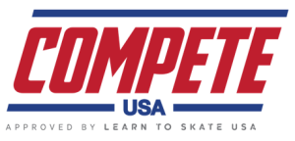

COMPETE USA EVENTS
Compete USA Solo Free Skate
Pairs
Compulsory/Elements
Showcase Solo Events: Light and Dramatic Artistic
Interpretive Event
Showcase Duets

The 6.0 Majority Judging System will be used for: All Compete USA Events

The 2019 Fort Collins Classic has been selected to be part of the 2019 Skate Colorado Compete USA Series

2019 Skate Colorado Compete USA Series
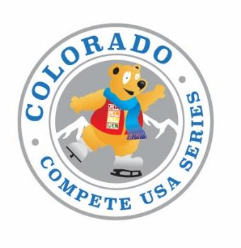
Denver Invitational (South Suburban)  Date: March 16-17, 2019  www.denverfsc.org  6580 So. Vine Street  Centennial, CO 80121  Competition Chair: Lisa May  lisa@denverfsc.org  (720) 272-0290  Competition Application Deadline: Feb 3, 2019 | Ft. Collins Classic (EPIC)  Date: April 4-7, 2019  www.fortcollinsfsc.org  1801 Riverside  Fort Collins, CO 80525  Competition Chair: Kelly Cann  kelly.cann79@gmail.com  (970) 237-9842  Competition Application Deadline: March 4, 2019
Colorado College Cup (Honnen Ice Arena)  Date: May 18, 2019  http:/www.coloradocollege.edu/other/honnen  14 Cache La Poudre St.  Colorado Springs, CO 80903  Competition Chair: Linda Alexander/Donna Schoon  lalexander@coloradocollege.edu or dschoon499@gmail.com  (719) 389-6156  Competition Application Deadline: April 18, 2019 | Front Range Invitational (Greeley Ice Haus)  Date: June 1, 2019  www.mountainviewskatingclub.com  900 8th Avenue  Greeley, CO 80633  Competition Chair: Leah Hurst  competition@mountainviewskatingclub.com  (970) 616-9101  Competition Application Deadline: May 12, 2019
Broadmoor Open (World Arena)  Date: June 23, 2019  www.broadmoorskatingclub.com  3185 Venetucci Blvd  Colorado Springs, CO 80906  Competition Chair: Barbara Bradley  HoneyB23@aol.com  719-540-5655  Competition Application Deadline: April 29, 2019 | Rocky Mountain Championships  (Ice Centre at the Promenade)  Date: Aug 3-4, 2019  www.rockymountainfsc.org  10710 Westminster Blvd  Westminster, CO 80020  Competition Chair: Alexandra Gilliam  ATGilliam2020@gmail.com  303-817-2821  Competition Application Deadline: June 14, 2019
Colorado Gold  Date: August 11, 2019  www.coloradoskatingclub.net  6580 So. Vine Street  Centennial, CO 80121  Competition Chair: Valerie Powell / Mike Maciolek  vailval@comcast.net / mcmaciolek@hotmail.com  (303) 596-0339 / (303) 915-9570  Competition Application Deadline: July 8, 2019 | Colorado Springs Invitational (Monument Ice Rinks)  Date: September 15, 2019  www.centennialskatingclub.org  16240 Old Denver Highway  Monument, CO 80132  Competition Chair: Lisa Landon  Lisa_landon@comcast.net  (719) 659-0912  Competition Application Deadline: Aug 5, 2019  *** All 2019 Skate Colorado Compete USA Competition Series awards will be presented at the conclusion of this competition ***

MISSION STATEMENT: To provide an opportunity for Colorado skaters to develop their skating skills in a fun, competitive environment.

AWARDS: During the competition season, skaters and teams/clubs will have the chance to compete at 8 different competitions and earn points for a final standing. Trophies and medals will be awarded at the conclusion of the CSI Skate Colorado Compete USA competition.

Skate Colorado Compete USA Series Team Banner (3x4) – 1st, 2nd, and 3rd place banners will be awarded to the club/skating school with the most points scored throughout the entire series (all 8 competitions) by skaters representing that club/skating school (points for clubs and skating schools located at the same rink will be added together to enhance and create more of a “team” concept). Points will be awarded based upon the same system as the individual points. Only the top 10 team members’ OVERALL scores FOR THE ENTIRE SEASON will count toward the team points for the determination of the team trophy. Tie breakers will be the same as the individual tie breakers.

Free skate Program and Elements/Compulsory
Series Point System

A skater must enter BOTH the Free skate Program AND the Elements/Compulsory event IN THE SAME LEVEL in each of at least TWO of the EIGHT registered Skate Colorado Compete USA Competitions to be eligible for accumulating points. Skaters must compete in a minimum of 2 competitions. Only up to the best 4 scores (free skate and compulsory/elements added together) of the season will be totaled for the final score in the series. Each event will have a maximum of six skaters. Both youth and adults may accumulate points!

The system for scoring points for the trophies will be as follows:
1st place 6 points
2nd place 5 points
3rd place 4 points
4th place 3 points
5th place 2 points
6th place 1 point

* A skater will earn three points toward their overall standing each time the skaters enters a level that is higher than the level competed in at the previous competition throughout the duration of the series. In order to keep the extra three points he/she must compete in that level or higher in all subsequent competitions. Move up points will be awarded for all 10 series events (even though the event point scores may not be one of the final four best scores).

In the event that there is only one skater in an event, the skater will have the choice to skate alone OR move up a level to compete against other skaters, HOWEVER, THE SKATER WILL HAVE TO MOVE UP IN BOTH THE ELEMENTS/COMPULSORY MOVES AND THE PROGRAMS W/MUSIC EVENTS. In this case, those skaters will be allowed to move back to their original level to compete at the next competition and shall not be awarded the 3 point move up credit.

If an event has 2-6 skaters, the points will be awarded as if there were six skaters in the group. If there is only one skater in the group, that skater will be awarded three points.

In case of a tie, the total number of skaters that the competitor has skated against throughout the series (all competitions and not just the competitions with the 4 best scores) will be the 1st tie breaker. The total score for all free skate events during the season will be the 2nd tie breaker, the total score for all compulsory events during the season will be the 3rd tie breaker, and the number of levels increased throughout the season will be the 4th tie breaker.

All points follow the skater throughout the series, so if a skater moves up to higher levels, the points follow the skater. Once a skater moves up a level, they may not compete at a lower level unless they moved up as a result of having no other skaters in their group.

Trophies will be awarded 1-3 in each level from Snowplow Sam through Free Skate 6 and Adult 1-6. The trophies will be awarded to the skaters at their level as of the last competition in which they compete.

Rules and Format:

COMPETITION ANNOUNCEMENT

The Skate Colorado Compete USA Competition Series is sponsored equally by the 8 participating ice rinks and/or U.S. Figure Skating member clubs. Competition packages will be available at all participating ice rinks and/or via the club or rink websites. Each competition will have its own entry forms and specific rules so please make sure to read the entire announcement for each competition.

ELIGIBILITY RULES FOR PARTICIPANTS

The competition is open to ALL skaters who are current eligible (ER 1.00) members of either the Learn to Skate USA Program and/or are full members of U.S. Figure Skating. To be eligible, skaters must have submitted a membership application or be a member in good standing. Members of other organizations are eligible to compete but must be registered with the host Learn to Skate USA Program/Club or any other Learn to Skate USA Program/Club.

Eligibility will be based on skill level as of the closing date of entries.

All Snowplow Sam through Basic 6 skaters are eligible to skate at highest level passed OR one level higher BUT not both levels in the same event during the same competition and NO official U.S. Figure Skating tests may have been passed including MIF or individual dances.

All Pre-Free Skate through Free Skate 6 skaters are eligible to skate at highest level passed OR one level higher BUT not both levels in the same event during the same competition. Skaters may have passed Pre-Preliminary MITF and no higher, Preliminary Dance and no higher, and may NOT have passed any U.S. FIGURE SKATING free skate tests.

It is very important to the success of the series that skaters are placed in the correct divisions. If, for whatever reason, the local organizing committee and/or their Chief Referee discover that a skater has been placed in a category that is below their class level, the chair and referee will have the option to move the skater to the proper division, even if this has to be done the day of the competition. This will ensure that every event is as fair as possible to the competitors.

SNOWPLOW SAM – BASIC 6 PROGRAM WITH MUSIC
Format: The skating order of the required elements is optional. The elements are not restricted as to the number of times the element is executed or length of glides, number of revolutions, etc., unless otherwise specified.
- To be skated on full ice with music.
- The skater may use elements from a previous level.
- A 0.2 deduction will be taken for each element performed from a higher level. Bonus skills from the same level or below are allowed but will not be judged elements.
- Divide Snowplow Sam skaters by level (1-4), if registrations warrant
Level | Time | Skating rules/standards
Snowplow Sam | 1:10 max. | - March followed by a two-foot glide and dip  - Forward two-foot swizzles, 2-3 in a row  - Forward snowplow stop  - Backward wiggles, 2-6 in a row
Basic 1 | 1:10 max. | - Forward two-foot glide and dip  - Forward two-foot swizzles, 6-8 in a row  - Beginning snowplow stop on two-feet or one-foot  - Backward wiggles, 6-8 in a row
Basic 2 | 1:10 max. | - Forward one-foot glide (no variations), either foot  - Scooter pushes, right and left foot, 2-3 each foot  - Moving snowplow stop  - Two-foot turn in place, forward to backward  - Backward two-foot swizzles, 6-8 in a row
Basic 3 | 1:10 max. | - Beginning forward stroking showing correct use of blade  - Forward ½ swizzle pumps on a circle, either clockwise or counterclockwise, 4-6 consecutive  - Forward slalom  - Moving forward to backward two-foot turn on a circle  - Beginning backward one-foot glide, either foot
Basic 4 | 1:10 max. | - Forward outside edge on a circle, clockwise or counterclockwise  - Forward crossovers, 4-6 consecutive, clockwise and counterclockwise  - Backward ½ swizzle pumps on a circle, either clockwise or counterclockwise, 4-6 consecutive  - Backward one-foot glides (no variations), right and left  - Beginning two-foot spin, maximum 4 revolutions
Basic 5 | 1:10 max. | - Backward outside edge on a circle, clockwise or counterclockwise  - Backward crossovers, 4-6 consecutive, clockwise and counterclockwise  - Forward outside three-turn, right and left  - Advanced two-foot spin, minimum 4 revolutions  - Hockey stop
Basic 6 | 1:10 max. | - Forward inside three-turn, right and left  - Bunny Hop  - Basic forward spiral on a straight line (no variations), right or left  - Beginning one-foot spin, maximum 3 revolutions, optional entry and free leg position  - T-stop, right or left

PRE-FREE SKATE – FREE SKATE 1-6 PROGRAM WITH MUSIC
Format: The skating order of the required elements is optional. The elements are not restricted as to the number of times an element is executed, length of glides, number of revolutions, etc., unless otherwise stated. Connecting steps and transitions should be demonstrated throughout the program.
- To be skated on full ice.
- The skater must demonstrate the required elements and may use but is not required to use any additional elements from previous levels.
- Bonus skills from the same level or below are allowed but will not be judged elements.
- A 0.2 deduction will be taken for each element performed from a higher level.
- Time 1:40 max.
Level | Time | Skating rules/standards
Pre-Free Skate | 1:40 max. | - Two forward crossovers into a forward inside Mohawk, step down and cross behind, step into one backward crossover and step to a forward inside edge, clockwise and counterclockwise  - Basic one-foot upright spin, optional entry and free-foot position- minimum 3 revolutions  - Mazurka  - Waltz jump  - NOT ALLOWED -Waltz jump, side toe hop, waltz jump
Free Skate 1 | 1:40 max. | - Forward stroking, 4-6 consecutive powerful strokes  - One-foot upright spin, entry from backward crossovers, with free foot in crossed leg position (scratch spin) - minimum 4 revolutions  - Toe loop jump  - Half flip jump  - NOT ALLOWED – Waltz jump/toe loop combination
Free Skate 2 | 1:40 max. | - Alternating forward outside spiral (right and left) and forward inside spiral (right and left) on a continuous axis  - Beginning back spin- maximum 2 revolutions  - Half Lutz  - Salchow jump  - NOT ALLOWED – Salchow/toe loop combination
Free Skate 3 | 1:40 max. | - Alternating Mohawk/crossover sequence, right to left and left to right  - Advanced back spin with free foot in crossed leg position, minimum 3 revolutions  - Loop jump  - Waltz jump/toe loop or Salchow/toe loop jump combination  - NOT ALLOWED – Waltz/loop combination
Free Skate 4 | 1:40 max. | - Forward power 3's, 2-3 consecutive sets, right or left  - Sit spin – minimum 3 revolutions  - Half Loop jump  - Flip jump  - NOT ALLOWED – Waltz/half-loop/Salchow sequence
Free Skate 5 | 1:40 max. | - Backward outside three-turn, Mohawk (backward power three-turn), both directions  - Camel spin – minimum 3 revolutions  - Waltz-loop jump combination  - Lutz jump
Free Skate 6 | 1:40 max. | - Creative step sequence using a variety of three turns, Mohawks and toe steps  - Camel, sit spin combination - minimum of 4 revolutions total  - Waltz jump/ half-loop/Salchow jump sequence  - Beginning Axel jump

SNOWPLOW SAM – BASIC 6 ELEMENTS
Two format options for the Elements Event:
- Each skater will perform each element when directed by a judge/referee OR
- Skater will perform one element at a time in the order listed below (no excessive connecting steps or choreography)
Judge/referee directed example: all skaters perform first element before moving on to the next and so on, or each skater performs all of the required elements before moving on to the next skater.
- To be skated on 1/3 to 1/2 ice (determined by the LOC)
- No music
- Divide Snowplow Sam skaters by level (1-4), if registrations warrant
All elements must be skated in the order listed

Level | Time | Skating rules/standards
Snowplow Sam | 1:00 max. | - March followed by a two-foot glide and dip  - Forward two-foot swizzles, 2-3 in a row  - Forward snowplow stop  - Backward wiggles, 2-6 in a row
Basic 1 | 1:00 max. | - Forward two-foot glide and dip  - Forward two-foot swizzles, 6-8 in a row  - Beginning snowplow stop on two-feet or one-foot  - Backward wiggles, 6-8 in a row
Basic 2 | 1:00 max. | - Forward one-foot glide (no variations), either foot  - Scooter pushes, right and left foot, 2-3 each foot  - Moving snowplow stop  - Two-foot turn in place, forward to backward  - Backward two-foot swizzles, 6-8 in a row
Basic 3 | 1:00 max. | - Beginning forward stroking showing correct use of blade  - Forward ½ swizzle pumps on a circle, either clockwise or counterclockwise, 4-6 consecutive  - Forward slalom  - Moving forward to backward two-foot turn on a circle  - Beginning backward one-foot glide, either foot
Basic 4 | 1:00 max. | - Forward outside edge on a circle, clockwise or counterclockwise  - Forward crossovers, 4-6 consecutive, clockwise and counterclockwise  - Backward ½ swizzle pumps on a circle, either clockwise or counterclockwise, 4-6 consecutive  - Backward one-foot glides (no variations), right and left  - Beginning two-foot spin, maximum 4 revolutions
Basic 5 | 1:00 max. | - Backward outside edge on a circle, clockwise or counterclockwise  - Backward crossovers, 4-6 consecutive, clockwise and counterclockwise  - Forward outside three-turn, right and left  - Advanced two-foot spin, minimum 4 revolutions  - Hockey stop
Basic 6 | 1:00 max. | - Forward inside three-turn, right and left  - Bunny Hop  - Basic forward spiral on a straight line (no variations), right or left  - Beginning one-foot spin, maximum 3 revolutions, optional free leg held position and entry  - T-stop, right or left

PRE-FREE SKATE – FREE SKATE 1-6 COMPULSORY
Format: In simple program form, using a limited number of connecting steps, the skating order of the required elements is optional.
- To be skated on ½ ice.
- No music
- The skater must demonstrate the required elements listed
- Bonus skills from the same level or below are allowed but will not be judged elements.
- A 0.2 deduction will be taken for each element performed from a higher level.
- Time: 1:15 maximum

Level | Time | Skating rules/standards
Pre-Free Skate | 1:15 max. | - Forward inside open Mohawk from a standstill position (R to L and L to R)  - Two forward crossovers into a forward inside Mohawk, step down and cross behind, step into one backward crossover and step to a forward inside edge, clockwise and counterclockwise  - Basic one-foot upright spin, optional entry and free-foot position - minimum 3 revolutions  - Mazurka  - Waltz jump
Free Skate 1 | 1:15 max. | - Forward stroking, 4-6 consecutive powerful strokes  - Backward outside three-turns, right and left  - One-foot upright spin, entry from backward crossovers, with free foot in crossed leg position (scratch spin) - minimum 4 revolutions  - Toe loop  - Half flip jump
Free Skate 2 | 1:15 max. | - Alternating forward outside spiral (right and left) and forward inside spiral (right and left) on a continuous axis  - Backward inside three-turns, right and left  - Beginning back spin- maximum 2 revolutions  - Half Lutz  - Salchow jump
Free Skate 3 | 1:15 max. | - Alternating Mohawk/crossover sequence, right to left and left to right  - Waltz three-turns, 2 sets clockwise and 2 sets counterclockwise  - Advanced back spin with free foot in crossed leg position- minimum 3 revolutions  - Loop jump  - Waltz jump/toe loop or Salchow/toe loop jump combination
Free Skate 4 | 1:15 max. | - Forward power 3's, 2-3 consecutive sets, right or left  - Sit spin - minimum 3 revolutions  - Half loop jump  - Flip jump
Free Skate 5 | 1:15 max. | - Backward outside three-turn, Mohawk (backward power three-turn), both directions  - Camel spin - minimum 3 revolutions  - Waltz jump-loop jump combination  - Lutz jump
Free Skate 6 | 1:15 max. | - Forward power pulls, minimum 3 on each foot  - Camel, sit spin combination - minimum of 4 revolutions total  - Waltz jump, ½ loop, Salchow jump sequence  - Beginning Axel jump

SHOWCASE EVENTS: Compete USA
General event parameters:
6.0 Judging will be used. Deductions will be made for skaters including technical elements not permitted in the event description.
* For specific guidelines regarding the conduct of Showcase competitions, refer to the Nonqualifying Showcase Guidelines posted on www.usfigureskating.org.
Showcase categories may include:
- Levels can be subdivided, if necessary, depending on entry numbers and event set up
- Dramatic entertainment: Showcase program utilizing intense emotional skating quality to depict choreographic theme.
- Light entertainment: Showcase program emphasizing such choreographic expressive qualities such as comedy, love and mime while incorporating skating skills.
- Duets: Theatrical/artistic performances by any competitors.
.
LEVEL | ELEMENTS | QUALIFICATIONS | PROGRAM LENGTH
Basic 1-6 | Elements only from Basic 1-6 curriculum | May not have passed any higher than Basic 6 level. | Time: 1:00 max.
Pre-Free Skate-Free Skate 6/ Beginner/High Beginner/ Adult 1-6 | 3 jump maximum. ½ rotation jumps only, plus the following full rotation jumps: Salchow and toe loop. | May not have passed any official U.S. Figure Skating free skate tests. | Time: 1:30 max.
No Test/  Pre-Preliminary/ | No prescribed or restricted elements. | Must have passed no higher than U.S. Figure Skating Pre-Preliminary. | Time: 1:30 max.
Adult Pre-Bronze  Adult Bronze  Preliminary | No prescribed or restricted elements. | Must have passed no higher than Adult Pre Bronze free skate test, Adult Bronze, or Preliminary. | Time: 1:40 max.

INTERPRETIVE
Competition Format
The Organizing Committee must pre-select and edit musical choices appropriate for these events. During the warm-up, skaters will hear the selection of music twice. Following the warm-up, all skaters except for the first skater will be escorted to a soundproof locker room or another area of the arena. The first skater will hear the music one more time and then perform a program to the music. As each skater performs, the next skater in line will be allowed to hear the music for the third time before they perform to the music. The listening skater will not be allowed to view the performing skater.
Levels: Levels should be broken by ability with ages divided appropriately.
Judging Rules: Skaters are judged on originality, pattern, technical (the ability to include jumps and spins) and music interpretation/expression.
Spins and jumps performed must be appropriate to competition level.
Time: Music Duration: Basic 1-6: 1:00 Max
Pre-Free Skate - No Test: 1:00 Max
Pre-Preliminary - Preliminary: 1:00 Max
Coaching: There is to be no instruction allowed during this event from coaches, parents, or fellow skaters. Staging area must be kept clear except for ice monitor and listening competitor.

ADULT 1-6 FREE SKATE WITH MUSIC
General event parameters:
- The skating order of the required elements is optional.
- The elements are not restricted to the number of times element is executed, or length of glides, number of revolutions, etc. unless otherwise stated. Connecting moves and steps should be demonstrated throughout the program.
- To be skated on full ice
- The skater must demonstrate the required elements and may use, but is not required to use, any additional elements from previous (lower) levels.
- A 0.2 deduction will be taken for each required element MISSING and for those elements performed from a higher level.

Level | Time | Elements
Adult 1 | 1:40 Max | - Forward Marching  - Forward two-foot glide  - Forward swizzle (4-6 in a row)  - Forward snowplow stop – two feet or one foot
Adult 2 | 1:40 Max | - Forward skating across the width of the ice  - Forward one-foot glides  - Forward slalom  - Backward skating  - Backward swizzles, 4-6 in a row
Adult 3 | 1:40 Max | - Forward stroking using the blade properly  - Forward half-swizzle pumps on the circle, 6 to 8 in a row, clockwise and counterclockwise  - Backward skating to a long two-foot glide  - Forward chasses on a circle, clockwise and counterclockwise  - Backward snowplow stop, Right and Left
Adult 4 | 1:40 Max | - Forward outside edge on a circle, right and left  - Forward inside edge on a circle, right and left  - Forward crossovers, clockwise and counterclockwise  - Backward one-foot glides, right and left  - Hockey stop, both directions
Adult 5 | 1:40 Max | - Backward outside edge on a circle, right and left  - Backward inside edge on a circle, right and left  - Backward crossovers, clockwise and counterclockwise  - Forward outside three-turn, right and left  - Beginning two-foot spin
Adult 6 | 1:40 Max | - Forward stroking with crossover end patterns  - Backward stroking with crossover end patterns  - Forward inside three-turn, right and left  - T-stop  - Lunge  - Two-foot spin into one-foot spin (min 2 revs on 1 foot)

ADULT BEGINNER – BRONZE FREE SKATE PROGRAM WITH MUSIC

General event parameters:
- Skaters will skate to the music of their choice and vocal music is allowed
- To be skated on full ice
- The minimum number of required spin revolutions is indicated in parentheses following the spin description. Revolutions must be in position.
Level | Jumps | Spins | Step Sequences | Qualifications
Adult Beginner  1:40 Maximum | Max. 4 jump elements  - Jumps limited to bunny hop, mazurka, ballet and Waltz jump  - Max 1 combination or sequence consisting of only the allowed listed jumps  - Max. 2 of any same jump | Max. 2 spins  - Two forward upright spins, no change of foot, no flying entry (Min. 3 revolutions) | Connecting moves and steps should be demonstrated throughout the program | Skaters may not have passed tests higher than U.S. Figure Skating Learn to Skate USA Free Skate 1
Adult High Beginner  1:40 Maximum | Max 4 jump elements:  - Jumps limited to bunny hop, mazurka, ballet, stag, split, waltz, ½ flip, ½ Lutz  - Max 1 combination or sequence consisting of only the allowed listed jumps  - Max. 2 of any same type jump. | Max 2 spins:  - Two upright spins, change of foot optional, no flying entry (Min. 3 revolutions) | Connecting moves and steps should be demonstrated throughout the program | Skaters may not have passed any U.S. Figure Skating Free Skate tests
Adult Pre-Bronze  1:40 Maximum | Max 4 Jump Elements:  - Jump combinations and sequences are optional, but no more than 2 combinations or sequences may be included  - 1 jump combination/sequence may consist of three jumps, and the other may have only two jumps.  - Each jump may be repeated only once and only as part of a combination or sequence (maximum of 2 of any jump)  - Only single and half-revolution jumps are allowed  - No single Lutz, single Axel or double jumps are allowed | Max 2 Spins:  - Max Level 1  - Spins must be of different character (for definition, see U.S. Figure Skating rule 4103 E) | Connecting steps throughout the program are required | Skaters may not have passed tests higher than U.S. Figure Skating Adult Pre-Bronze or Pre-Preliminary Free Skate
Adult Bronze  1:50 maximum | Max 4 Jump Elements:  - Max 2 combinations or sequences;  - 1 combination/sequence may consist of three jumps, and the other may have only two jumps  - Each jump may be repeated only once, and only as part of a combination or sequence (maximum of 2 of any jump)  - All single jumps are permitted (except single Axel)  - No single Axel, double or triple jumps are permitted | Max 2 Spins:  - Max Level 1  - Spins must be of different character (for definition, see U.S. Figure Skating rule 4103 (E))  - Min 3 revs total if no change of foot  - Min 3 revs each foot if change of foot  - Min 2 revs in each position  - No flying spins are permitted | Max 1 Sequence:  - Choreographic Step Sequence  Must use at least ½ ice surface  May include Moves in the Field and spirals | Skaters may not have passed tests higher than U.S. Figure Skating Adult Bronze or Preliminary Free Skate

ADULT 1-6, BEGINNER-BRONZE COMPULSORY
- The skating order of the elements is optional. Element may only be attempted once.
- To be skated in simple program format with limited connecting steps, ½ ice.
- A 0.2 deduction will be taken for each element MISSING, REPEATED or from a higher level
Level | Time | Elements
Adult 1 | 1:30 Max. | - Forward Marching  - Forward two-foot glide  - Forward swizzle (4-6 in a row)  - Forward snowplow stop – two feet or one foot
Adult 2 | 1:30 Max. | - Forward skating across the width of the ice  - Forward one-foot glides  - Forward slalom  - Backward skating  - Backward swizzles, 4-6 in a row
Adult 3 | 1:30 Max. | - Forward stroking using the blade properly  - Forward half-swizzle pumps on the circle, 6 to 8 in a row, clockwise and counterclockwise  - Forward chasses on a circle, clockwise and counterclockwise  - Backward skating to a long two-foot glide  - Backward snowplow stop, Right and Left
Adult 4 | 1:30 Max. | - Forward outside edge on a circle, right and left  - Forward inside edge on a circle, right and left  - Forward crossovers, clockwise and counterclockwise  - Hockey stop, both directions  - Backward one-foot glides, right and left
Adult 5 | 1:30 Max. | - Backward outside edge and backward inside edge on a circle, right and left  - Backward crossovers, clockwise and counterclockwise  - Forward outside three-turn, right and left  - Beginning two-foot spin (min 2 revs)
Adult 6 | 1:30 Max. | - Forward stroking with crossover end patterns  - Backward stroking with crossover end patterns  - Forward inside three-turn, right and left  - T-stop  - Lunge  - Two-foot spin into one-foot spin (min 2 revs on 1 foot)
Adult Beginner | 1:30 Max. | - Bunny hop  - Mazurka  - Forward beginning one-foot spin from backward crossovers (min 2 revs)  - Forward moving inside open Mohawk (right and left) – heel to instep  - Alternating right and left forward outside and inside edges across the width of the ice (one outside edge, right and left, one inside edge, right and left)
Adult High Beginner | 1:30 Max. | - Waltz Jump  - ½ Flip  - Forward upright spin – minimum 3 revolutions  - Backward outside three- turn, right and left  - Alternating right and left backward outside and inside edges across the width of the ice (one outside edge, right and left, one inside edge, right and left)
Adult Pre-Bronze | 1:30 Max. | - Toe loop jump  - Jump combination or sequence consisting of only ½ revolution jumps (half loop is considered a full revolution jump) – maximum of 2 jumps in combination and 3 jumps in a sequence  - Forward upright spin - minimum 3 revolutions  - Two forward crossovers into a forward inside Mohawk, step down, cross behind, step into one backward crossover and step to a forward inside edge, clockwise and counterclockwise  - Forward spiral (any edge)
Adult Bronze | 1:30 Max. | - Salchow jump  - Waltz jump – toe loop combination jump  - Backward Upright Spin – entry optional (Min. 3 revolutions)  - Backward inside three-turn, right and left  - Spiral sequence (Minimum 2 spirals)- must change edge or foot

