­­­

**HHWC North Lakes Area**

Phone: 218-568-5648

Fax: 218-568-5698

Frontdesk@Lakeswellness.com

31108 Government Drive

Pequot Lakes, MN 56472

**DMR Clinic Woodbury**

Phone: 651-621-8803

Fax: 651-757-4099

Darak@DMRwoodbury.com

1687 Woodlane Drive, Suite 201

Woodbury, MN 55125

**Hopkins Health & Wellness**

Phone: 952-933-5085

Fax: 952-931-2159

[PT@HopkinsWellness.com](mailto:PT@HopkinsWellness.com)

15 8th Avenue North

Hopkins, MN 55343

Name: _________________________________________________________Date of Birth: _____________________

Diagnosis: ___________________________________________ Dx Codes: ___________________________________

Onset/DOI: ____________________ Insurance: ___________________ Phone Number: _______________________

Evaluate & Treat Frequency: _____/wk Duration: _____ Weeks Total Visits: _____ __________________________

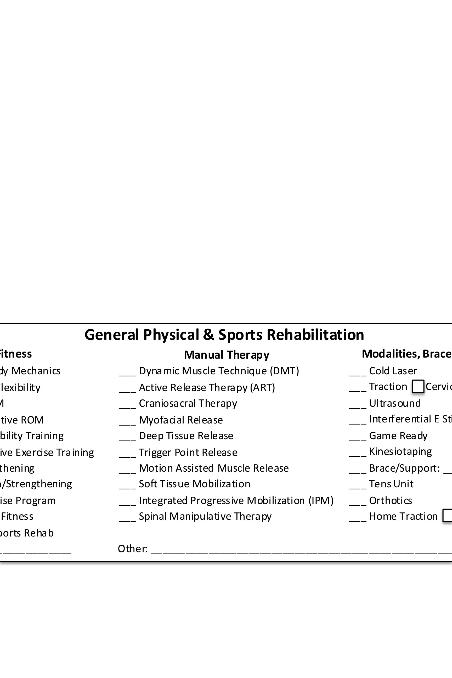c

c

c

c

**Modalities, Braces & Supplies**

___ Cold Laser

___ Traction Cervical Lumbar

___ Ultrasound

___ Interferential E Stim

___ Game Ready

___ Kinesiotaping

___ Brace/Support: _____________

___ Tens Unit

___ Orthotics

___ Home Traction Cerv Lumb

**Manual Therapy**

___ Dynamic Muscle Technique (DMT)

___ Active Release Therapy (ART)

___ Craniosacral Therapy

___ Myofacial Release

___ Deep Tissue Release

___ Trigger Point Release

___ Motion Assisted Muscle Release

___ Soft Tissue Mobilization

___ Integrated Progressive Mobilization (IPM)

___ Spinal Manipulative Therapy

**Exercise/Fitness**

___ Posture/Body Mechanics

___ Stretching/Flexibility

___ Passive ROM

___ Active/Assistive ROM

___ Balance/Stability Training

___ Proprioceptive Exercise Training

___ Core Strengthening

___ Stabilization/Strengthening

___ Home Exercise Program

___ Progressive Fitness

___ Return to Sports Rehab

______________________ Other: ________________________________________________________________

**General Physical Therapy & Sports Rehabilitation**

**Chiropractic Integrated Progressive Mobilization (IPM)**

**Massage Therapy**

Deep Tissue Sports Myofacial Craniosacral

**Dry Needling**

Area: _________________________________________

**Other Services**

This form is a Prescription and a Statement of Medical Necessity and is valid with any licensed physical therapist in Minnesota.

Physician Name: _______________________________

Signature: ________________________Date: _______

Clinic: ___________________ Fax: ________________

**DMR Method**

**DMR Method Evaluate and Treat**

**Lumbar Cervical Other: _________________________________________________________________**

Acute Chronic

Limited (6-12 visits) strain/sprains, non-radicular pain, minor sports injuries

Progressed (12-20 visits) facet syndrome, headaches, sciatica, cervicobrachial syndrome

Advanced (20-24 visits) disc herniation, DDD, spondylolisthesis, stenosis, post-operative

Special instructions: __________________________________________________________________________