A PAIN FREE PLUS SERIES:
CORRECTIVE SOMATIC MOVEMENT PRACTICES for BETTER BACKS and PELVIC BALANCE
Align Your Posture, Ease Your Pain to Reclaim the Life You Love! Four MONDAYS, MARCH 9 – 30 from 11:15PM – 12:45PM
$99 mbr / $129 n-mbr
To sign up please contact Alan at alanf@jccnh.org or by phone at 203.980.8853
Much of chronic back pain, joint degeneration, and recurring injuries are caused by the way we use our bodies – the way we sit, stand, and move throughout our lives. The more we repeat a certain posture or movement, the more deeply learned that muscular pattern becomes and the only way to change these deeply learned muscular patterns is to re-educate the nervous system.
Somatic movement engages the nervous system in an active learning process that consists of very slow, focused, conscious movements. The movement techniques used teach the nervous system how to release chronic muscle tension and stand and move in natural, efficient ways so that you aren’t putting yourself in pain or doing damage to your body.
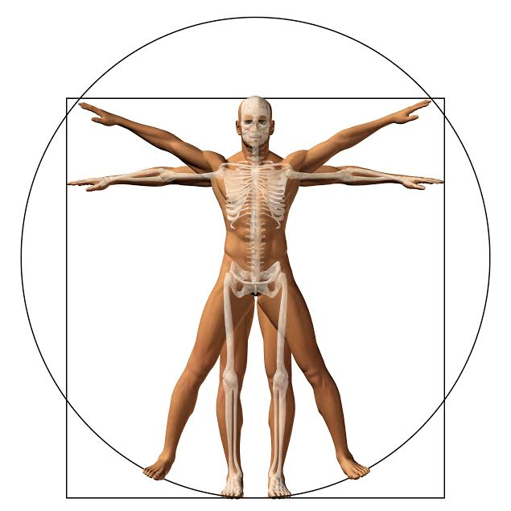
In this 90 minute workshop, you will experience easy, positional movements, stretches, and other therapeutic exercises designed specifically to restore postural alignment, function, and to address pain problems at their root cause.
Workshop is limited to a maximum of 8 participants
Alan Franzi, MS, PAS, C-IAYT​ brings over 25 years’ experience ​to his clients. He is a Certified Posture Alignment Specialist (PAS), trained through the Egoscue® Institute​ with​ additional specialized training as​ a Level 1 Somatic Movement Center® Certified Exercise​ Specialist and a ​​Certified Yoga Therapist(C-IAYT) ​ ​His “Pain Free Posture” therapy work reflects his passion to help those with chronic pain, ​and ​progress on their path toward pain free living and a fuller​,​ more active lifestyle.

