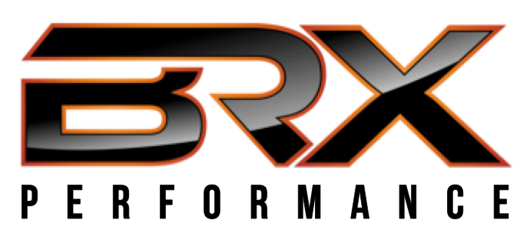
BRX Performance
Internship Information

Whereas many fitness industry internships consist of taking out the trash and pushing a broom in a corner for a large portion of the workday, an internship at BRX Performance will help prepare you for your future each and every day. In terms of developing as a personal trainer/strength coach, interns will be exposed to everything from professional and youth athletes, 1-on-1 training, program design, and assessment protocol. In addition to training experience, interns will also be exposed to the business/sport management side of the fitness industry, like marketing, using online software systems for scheduling and client database management, resume building, selling your services, and much more.

Expectations/Responsibilities
- Guiding clients through warm-up and strength exercises
- An ability to be personable on a consistent basis
- An eagerness to learn
- A willingness to interact with clients and parents in addition to approaching/assisting those demonstrating poor exercise form
- Presenting yourself well in front of impressionable youth athletes
- Assisting with facility maintenance

Duration
- BRX Performance internships are scheduled in accordance with academic semesters and can be flexible with your needs/schedule/academic requirements

BRX Performance Hours (subject to change)
Oconomowoc
2:30pm-8:00pm Monday-Thursday
2:30pm-7:00pm Friday
11:00am-2:00pm Saturday
Dates (dates subject to discussion)
Fall Semester – September 5th – December 18th
Spring Semester – January 4th – May 19th
Summer Semester – May 22nd – August 29th
Other Info
- Unpaid
- Could potentially turn into employment at conclusion of internship

If you are interested, please fill out the application on the next page in Word and save/send as a PDF file to Josh@BRXperformance.com along with your resume. If your application is considered, an in-person, Skype, or FaceTime interview will be conducted and a final decision will be made following.

BRX Performance
Internship Application

1. Applicant name ENTER NAME

2. Address ENTER ADDRESS

3. Phone ENTER PHONE NUMBER

4. Email address ENTER EMAIL

5. Current or most recent academic institution attended:

ENTER INFORMATION

6. Degree deceived/to be received ENTER INFORMATION

7. Academic status
☐Freshman ☐Graduate student
☐Sophomore ☐Undergraduate degree
☐Junior ☐Graduate degree
☐Senior

8. What semester are you interested in applying for:
Fall ☐
Spring ☐
Summer ☐

9. In a cover letter, explain why you are a qualified applicant and what makes you a great fit for BRX Performance. What makes you unique? What do you bring to the table that would bring value to our company? What do you hope to take away from the internship experience?

10. Lastly, please send above completed information to
info@brxperformance.com, along with cover letter, resume and references
attached in PDF form. We receive a lot of applications please allow two weeks for
response time.

